**Using Microsoft Teams**

## Table of Contents

Signing into Microsoft (Office) 365 2

Teams Screen 6

Creating a Class and Adding Members 7

General Channel………………………………………………………………………………17

Creating Posts 18

Adding Files and Folders 20

Adding Additional Channels 27

Scheduling Meetings 32

Running your Teams Meeting 39

Assignments 50

Chats 58

Meet now (Instant Meetings) 61

Breakout Rooms Online 63

Breakout Rooms on the Teams App…………………………………………………70

# Signing into Microsoft (Office) 365

Go to [www.office.com](http://www.office.com/) and sign in

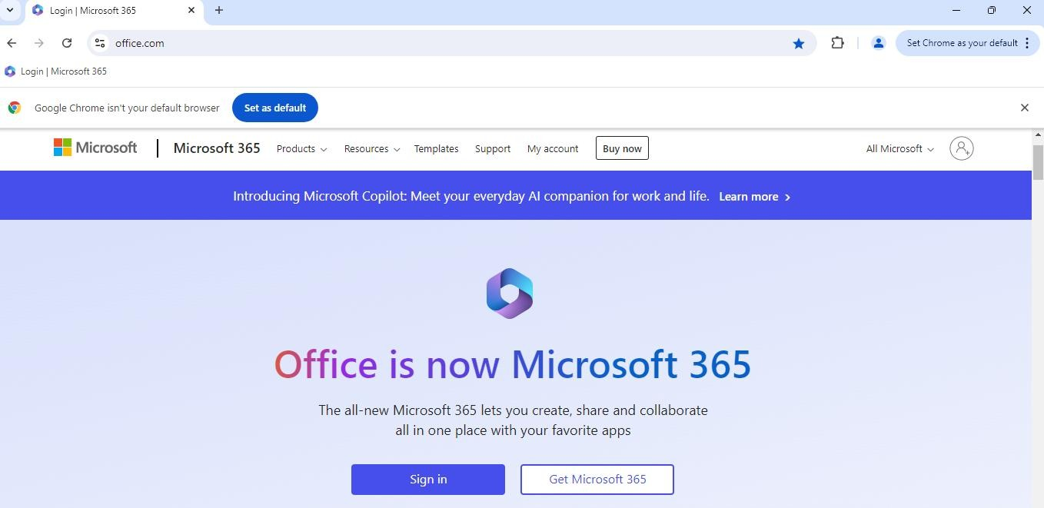

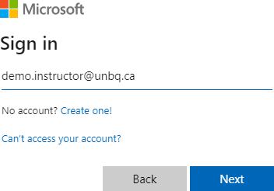

Your sign in name is your unbq.ca email. For example: [firstname.lastname@unbq.ca](mailto:firstname.lastname@unbq.ca) Type in your email address and click on the **Next** button.

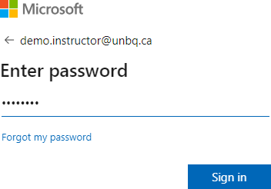

Enter your password and click on the **Sign in** button.

If this is the first time you are signing in, please refer to the Instructions for Instructors Signing into Office 365 handout.

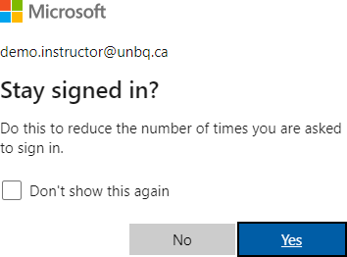

If you are using your own device, it is okay to stay signed in. If you are using a shared device (such as the computers in the BQ classrooms) you should not stay signed in

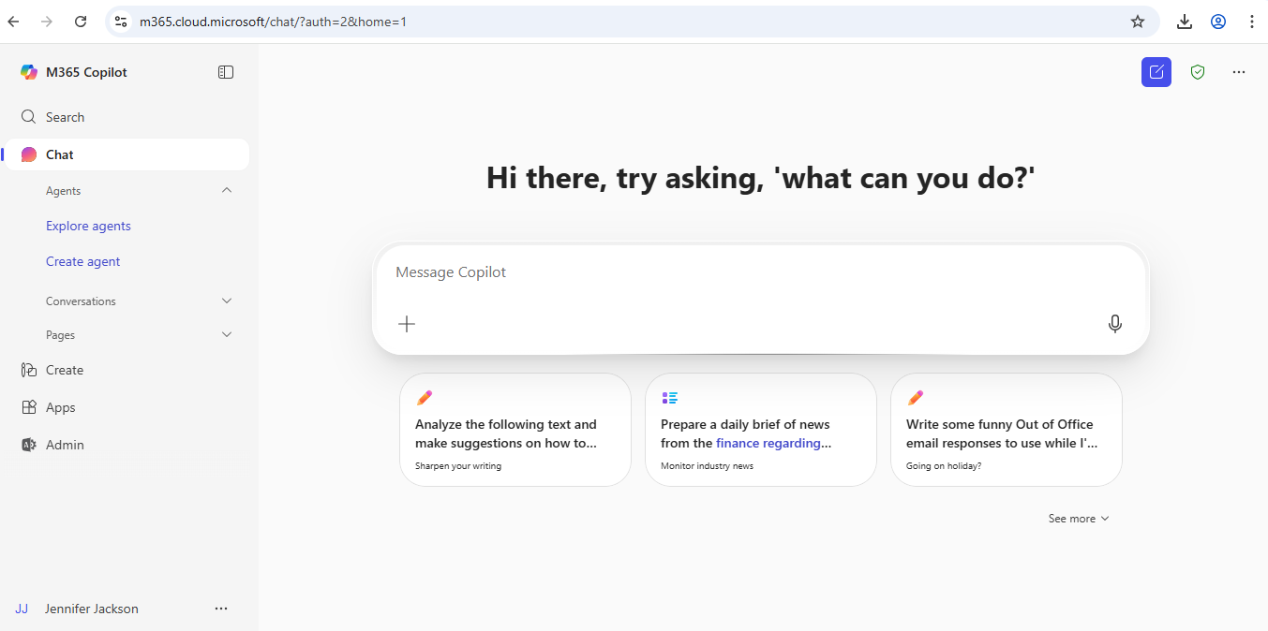

Click on the Apps button to access all your apps, such as Teams and Outlook.

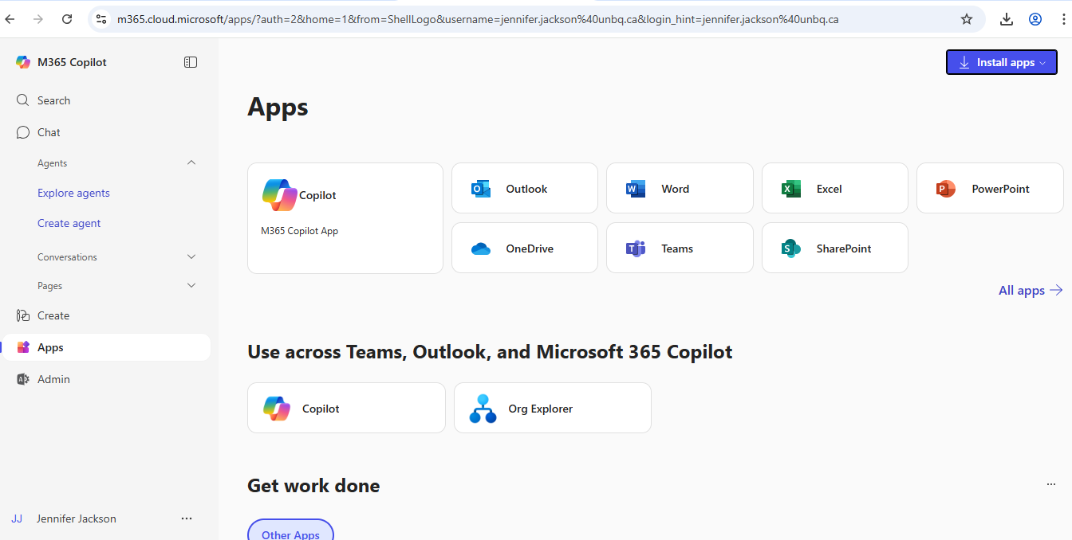



# Teams Screen

**Note:** Microsoft is currently making changes to the platform. Some windows may look different.

You will see one of the following 2 screens: Figure 1

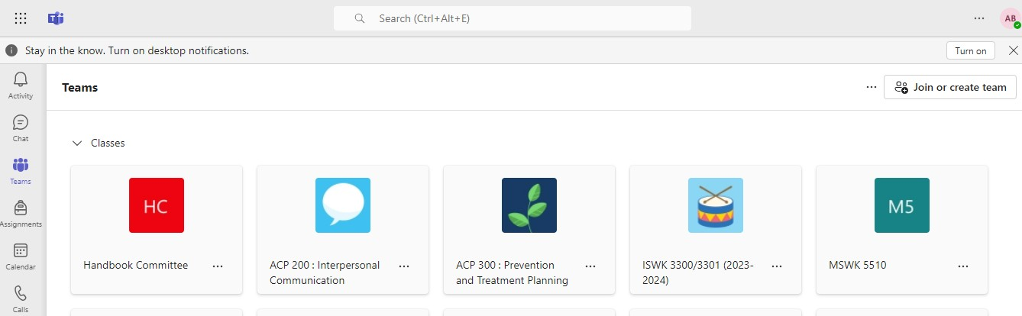

## Or

Figure 2

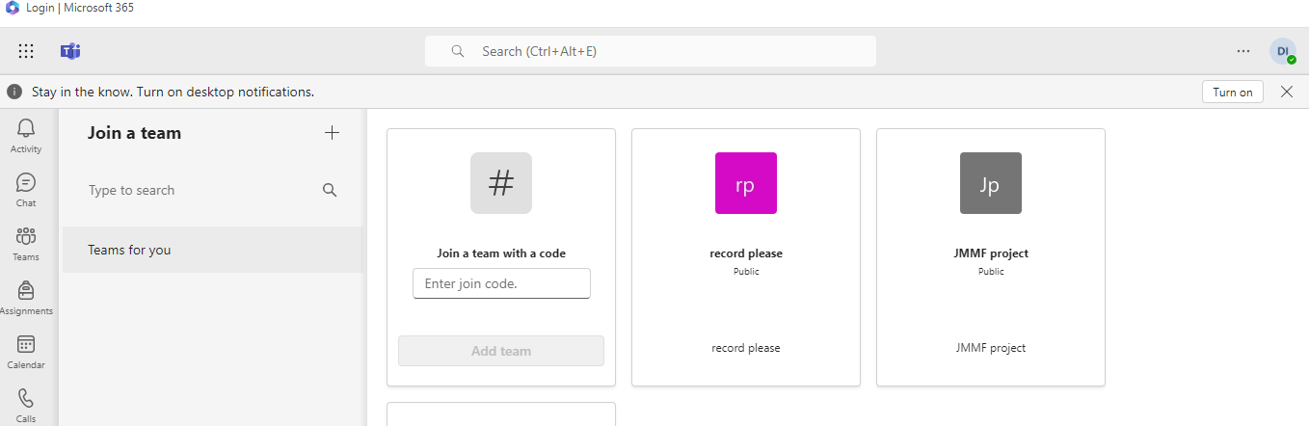

**Creating a Class (Figure 1)**

Click on the **Join or create team** button and select **Create team**

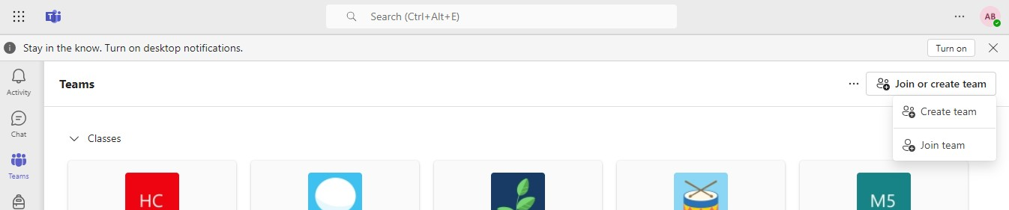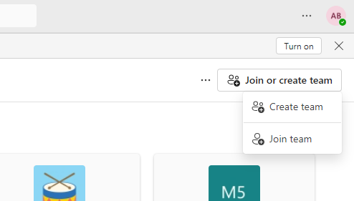

**Creating a Class (Figure 2)**

Click on the **+** to the right of Join a team

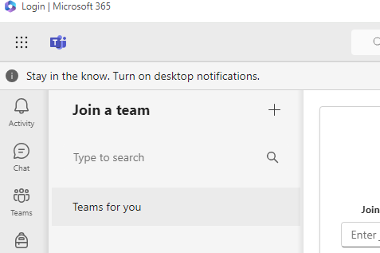

Select **Class**

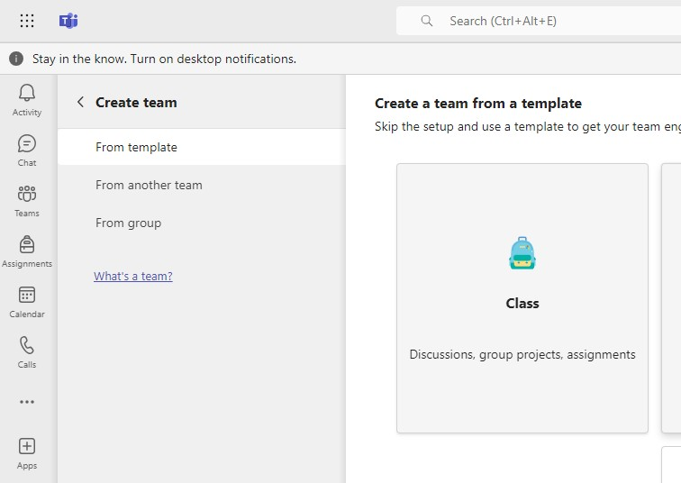

Click on **Use this template**

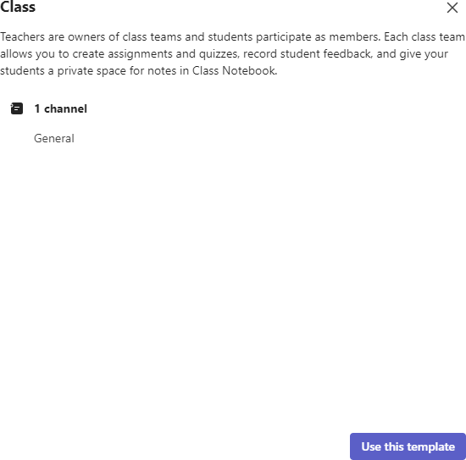

Type in the Team name and description (optional) then click **Create**

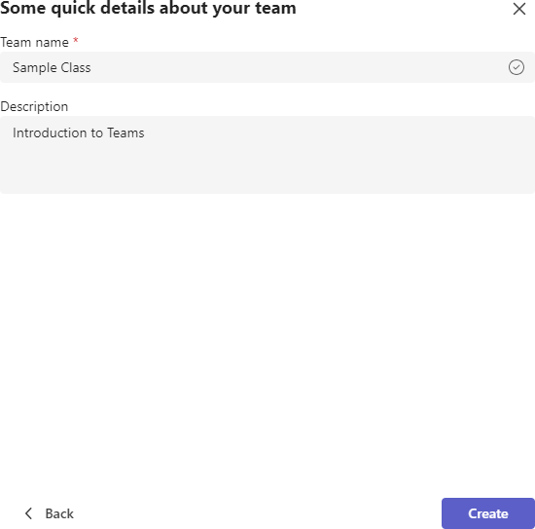

You can add your students here or Skip and do that in a later step. To add students here click in the Type a name or email box.

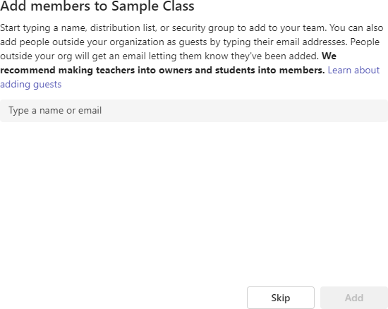

As you type the name you will see a list of suggested names to choose from.

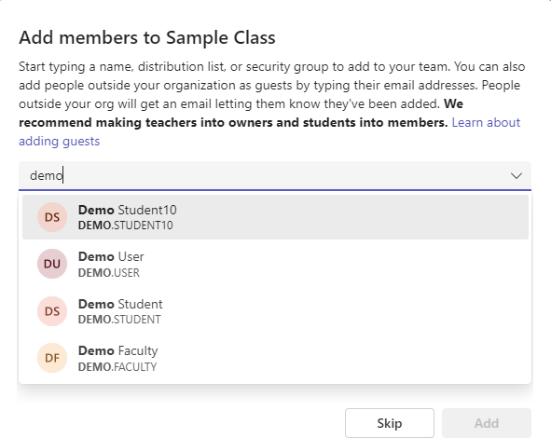

Click on a name in the list to select it and the click on the **Add** button to add the student to your class. Repeat until all students have been added.

You can also add both students (members) and other teachers (Owners) by going to the **More options** button (3 dots) that appears to the right of your Teams name in the main screen of your Teams window.

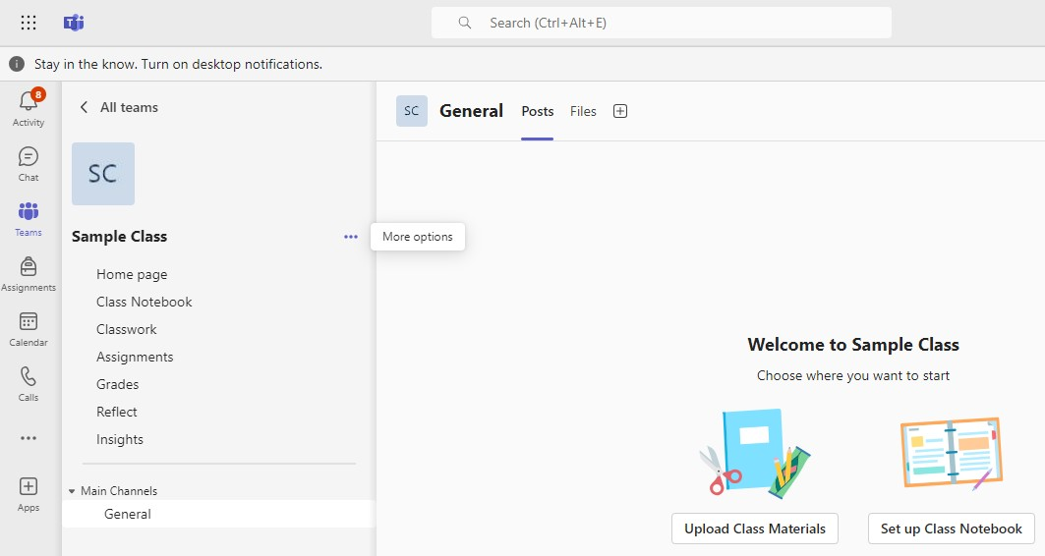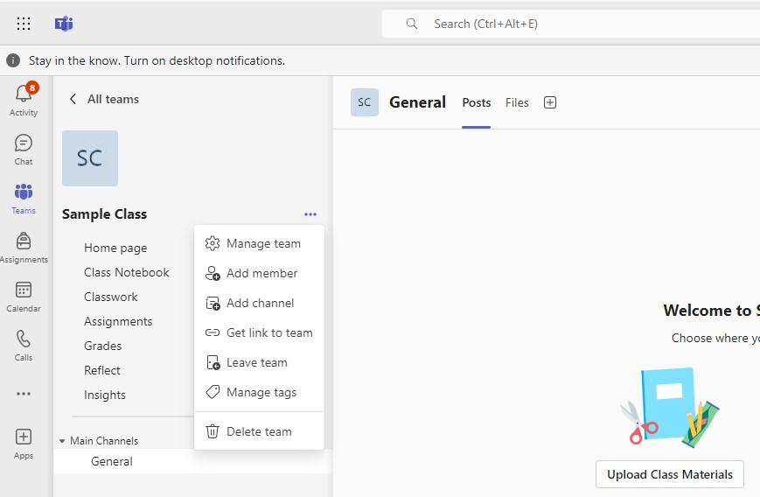

Select **Manage team** to add both students and other teachers. **It is recommended that you add** [**jennifer.jackson@unbq.ca**](mailto:jennifer.jackson@unbq.ca) **and** [**anne.blower@unbq.ca**](mailto:anne.blower@unbq.ca) **as owners to**

## your Team. If IT support or troubleshooting is needed it is easier to help if there is access to the class.

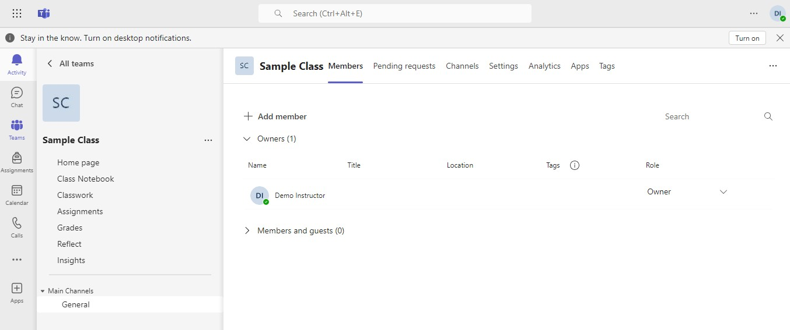

Click on the **+ Add member** button to add both students and teachers.

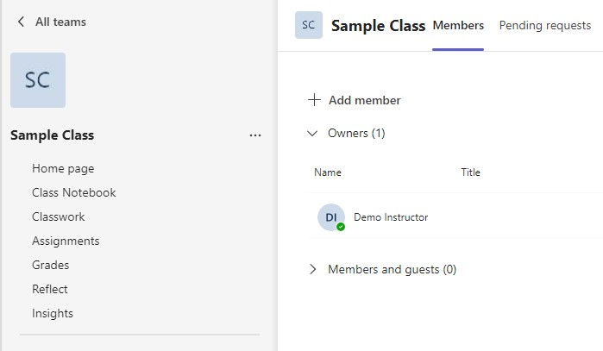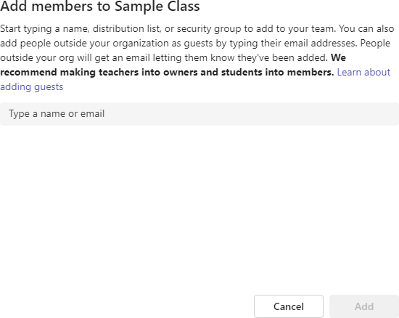

Click in the Type a name or email box. Begin typing the name of the teacher or student you wish to add. Select the person you wish to add from the list of suggested names.

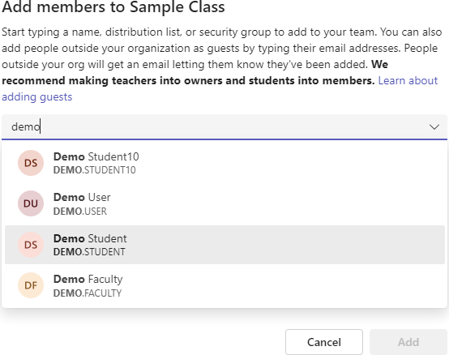

You can add people one at a time by selecting their name, selecting their role, and then clicking on the **Add** button. You can also select several names, select their role, and then click on the **Add** button.

If you add someone to the list by mistake you can remove them by clicking on the X beside their name.

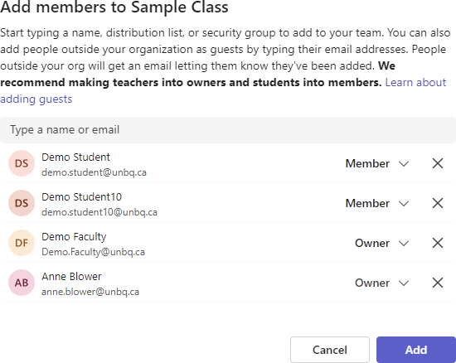

Role

In the example above I selected 2 students who are members, an additional teacher who is an owner, and Anne Blower (IT) as an owner.)

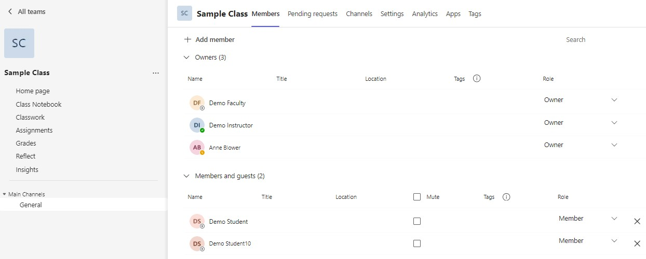

You can return to Manage team at any time to add or remove someone. You can also return to change someone’s role.

# General Channel

The General Channel is the main Teams screen.

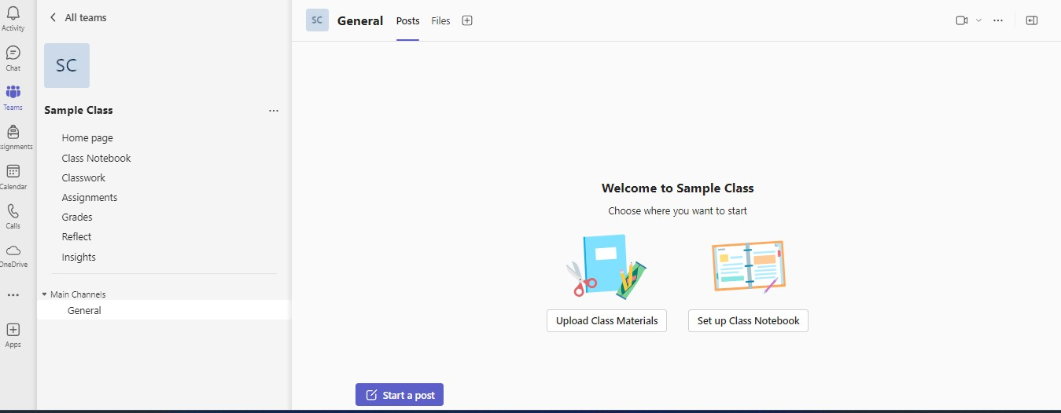

You can add Posts to the General Channel as well as upload Files. Unless you have created other channels your links to join Meetings will appear here as well as any recordings. There will also be notices for assignments.

# Creating Posts

You can click on the Start a post button to provide information for all members of your class to see.

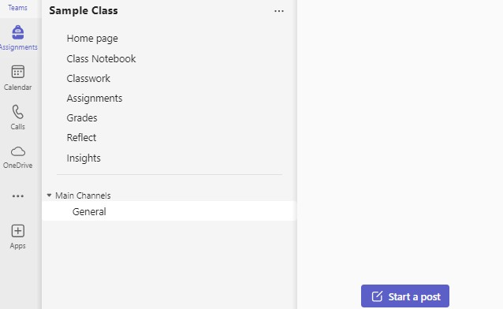

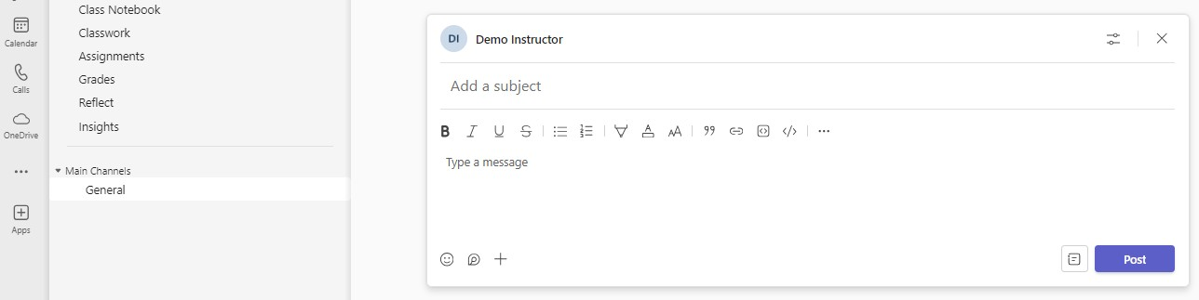

Add a subject to your post and then type in your message. (Just like an email) Click on the Post button when you are finished.

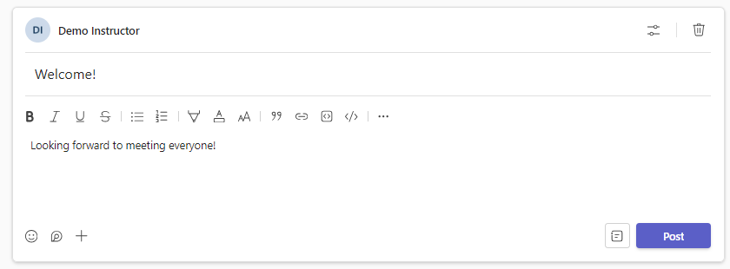

This is what everyone will see in the General Channel when they go to the Team.

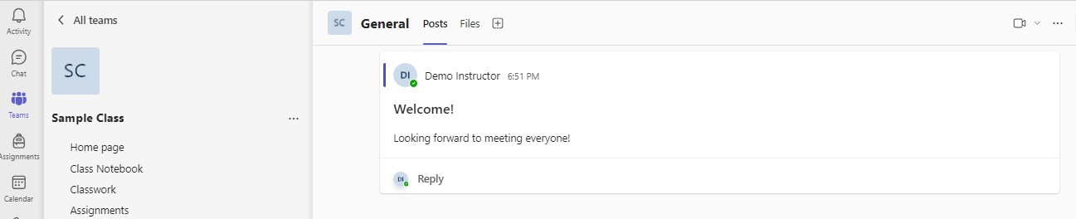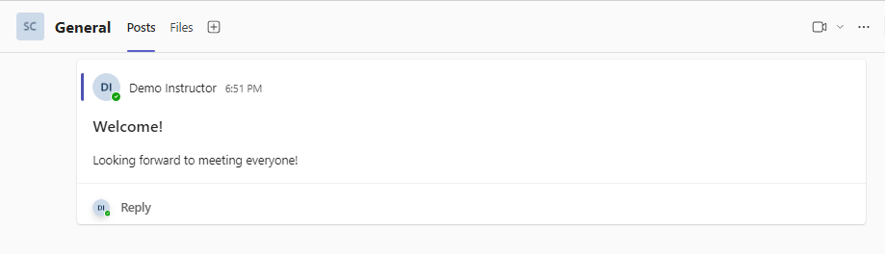

You can also use the Chat feature to converse with individuals or groups. See page 58.

# Adding Files and Folders

To add files to the General Channel (or any channel) click on **Files** at the top of the General Channel window.

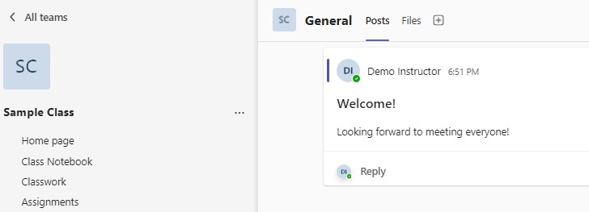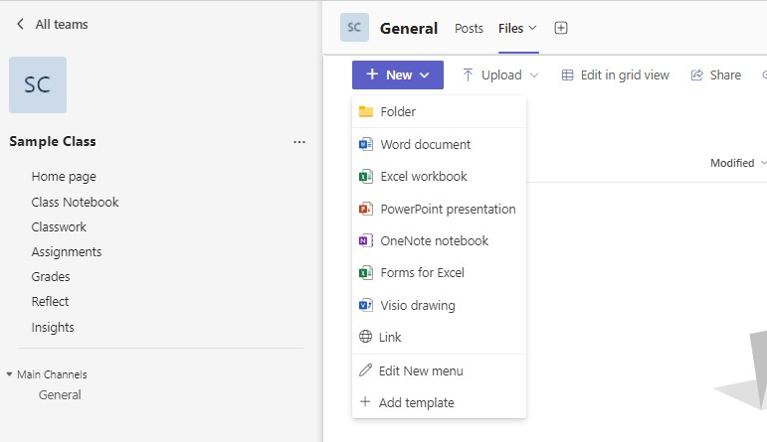

You can create new folders and different types of new files by clicking on the **New**

button.

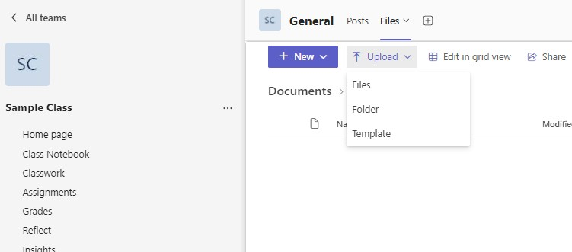

You can upload files, folders, and templates that you already have on your computer by clicking on the **Upload** button. In the example below I clicked on the Upload button and selected folder.

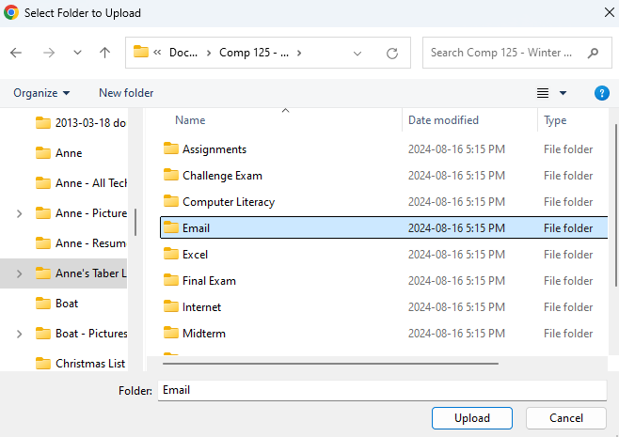

I then navigated to the folder I wanted and when I click on the **Upload** button the folder and all of the files in it will be added to my Team. You will see the following warning:

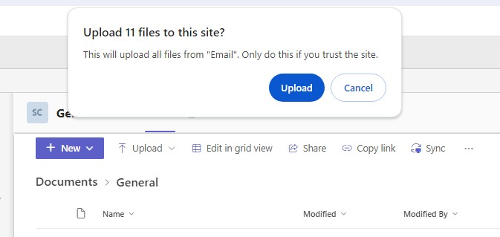

Click on **Upload** to complete the process.

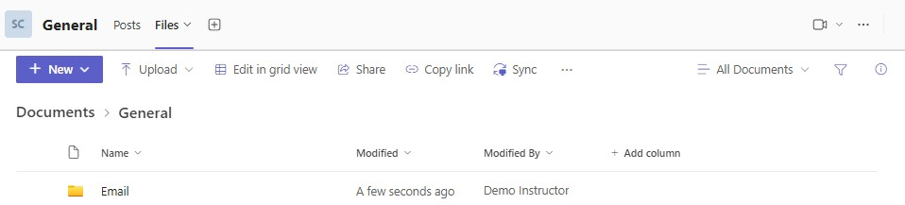

When you click on the folder you will see all of the files that were copied with the folder when you uploaded it.

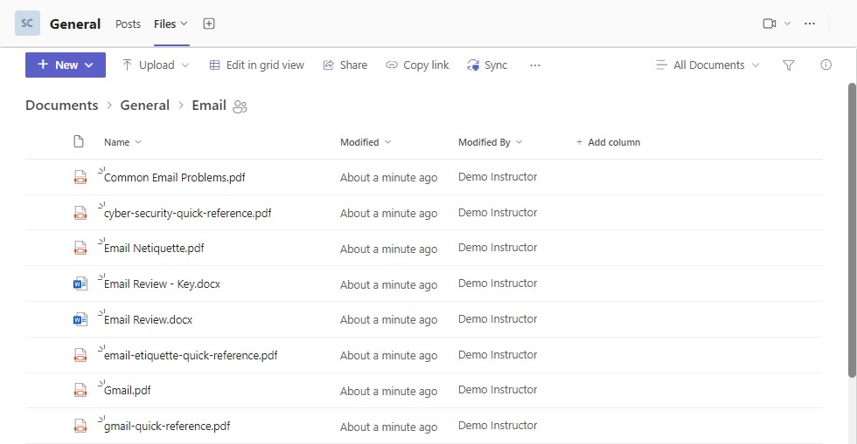

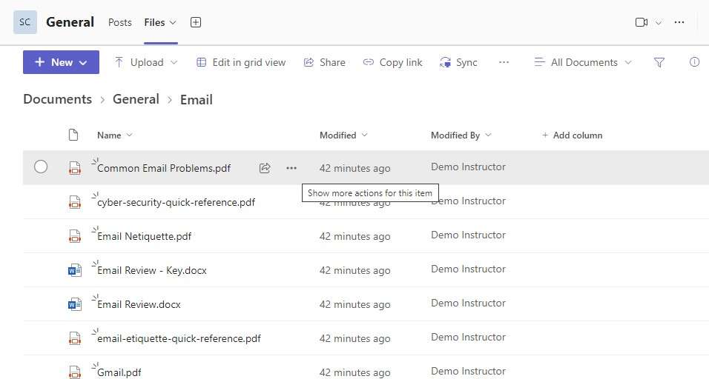

Beside every file are 3 dots (this is the **Show more actions for this item** button). When you click on the 3 dots there are a number of things you can do with your files.

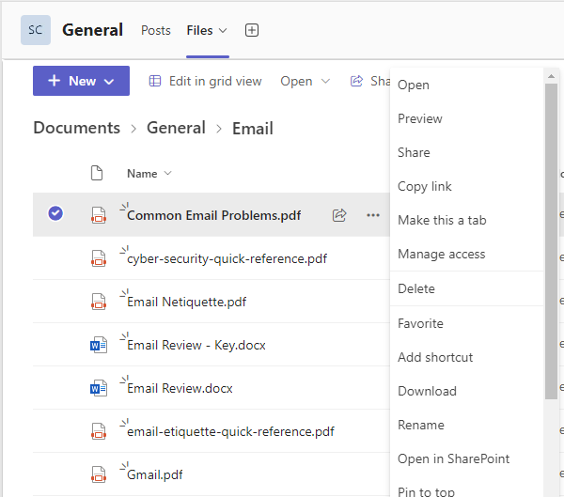

One of the things you might want to do is make a file read-only. This way students can view the file but cannot change it. Click on **Manage access** to change how the student is able to access the file.

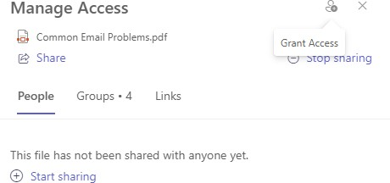

Click on the **Groups** tab to go to the next step.

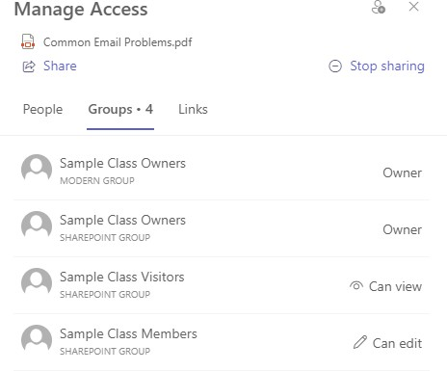

The Members (students) Can edit. If you want to change the file to read-only click on **Can edit**.

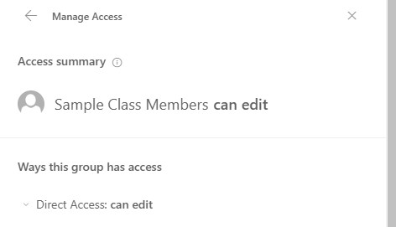

Now click on **Direct Access can edit**

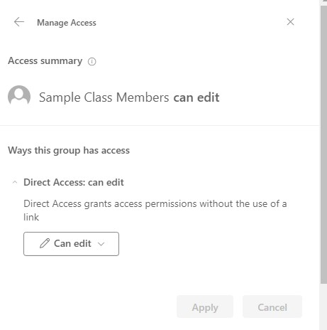

Click on the **Can edit** button

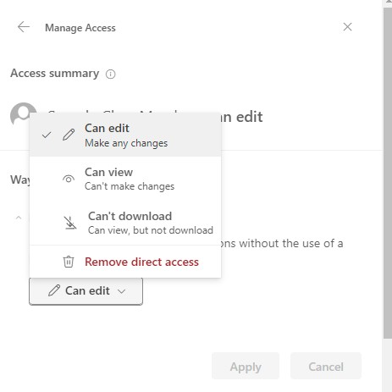

Click on **Can view** to make the file read-only. (You can also choose Can’t download if you don’t want the students to download the file.)

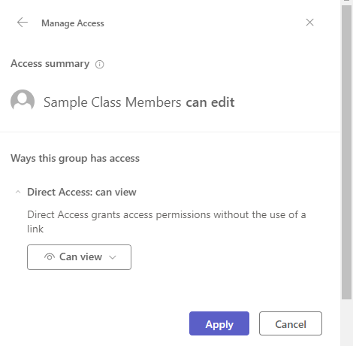

Click on the **Apply** button to complete the step.

# Adding Additional Channels

In addition to the General Channel that comes with every class you can also create additional channels.

Channels organize all the files, conversations, and meeting links for a topic in one place. Channels can be created for topics, units, projects, and more.

To create a channel, click on the **More options** button and the select **Add channel**.

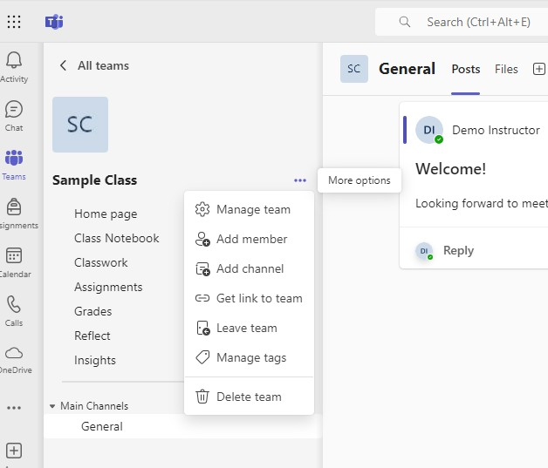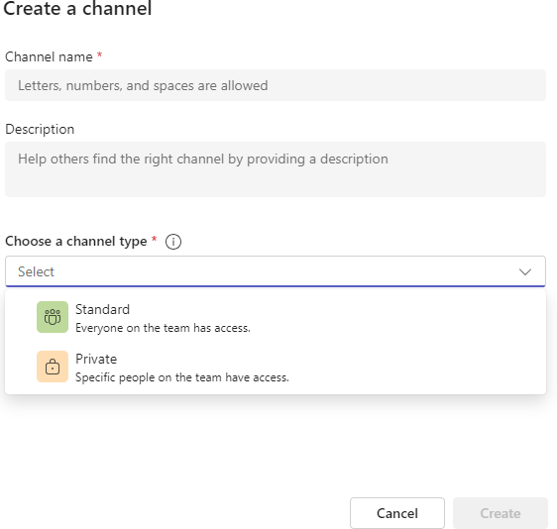

**Type in a name for your channel under Channel name**. You can also include a description. **Choose a channel type**. **The usual choice is Standard**; this gives everyone in your class access to the channel. You would use Private if you are setting up group projects for only some of your class.

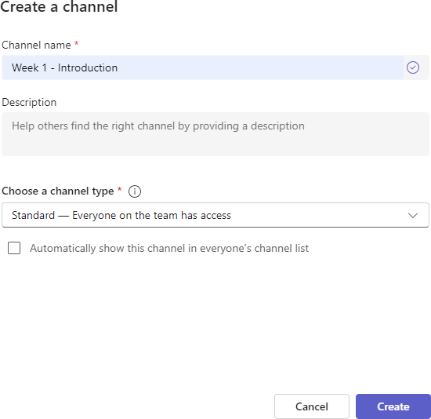

## You need to check the Automatically show this channel in everyone’s channel list option before you click on Create. If you miss this step your students will not see the channels you set up when they go to the class. (Sometimes the student will need to click on Hidden to see the channels).

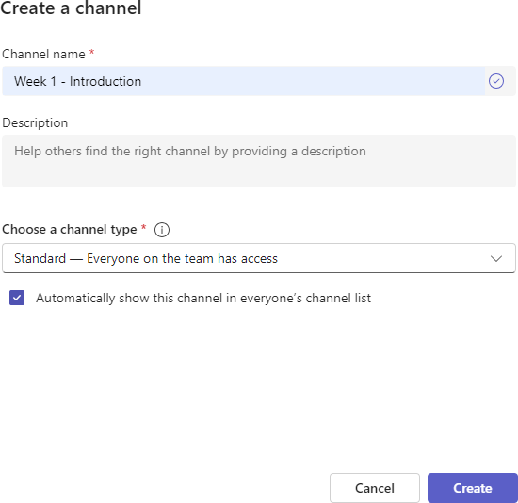

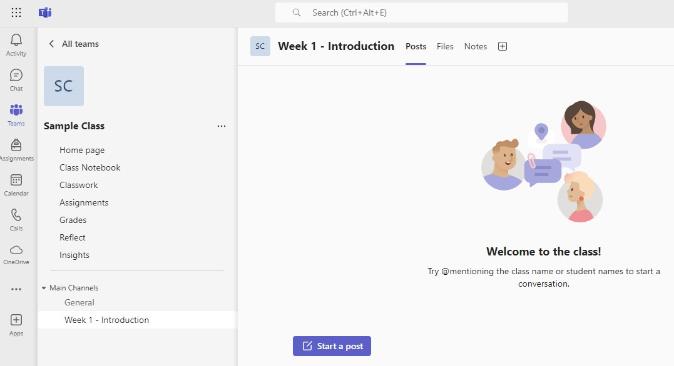

You can add posts to the channel you created as well as upload files to the channel. You can create meetings and add them to specific channels. Assignments can also be created and assigned to specific channels.

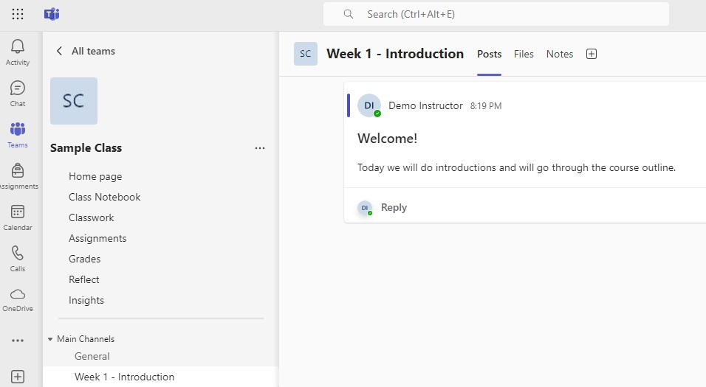

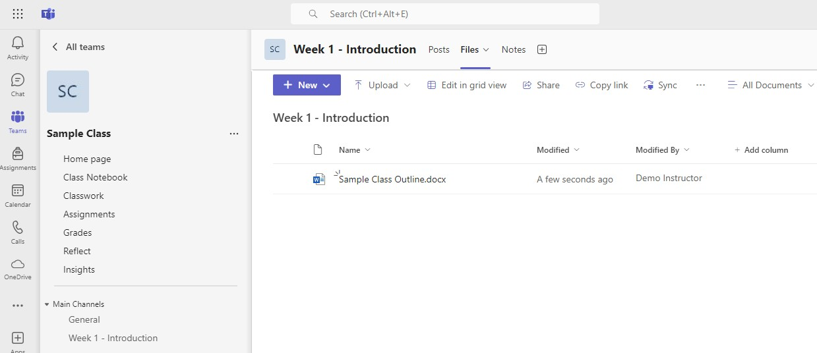

# Scheduling Meetings

Meetings can be created in the Calendar.

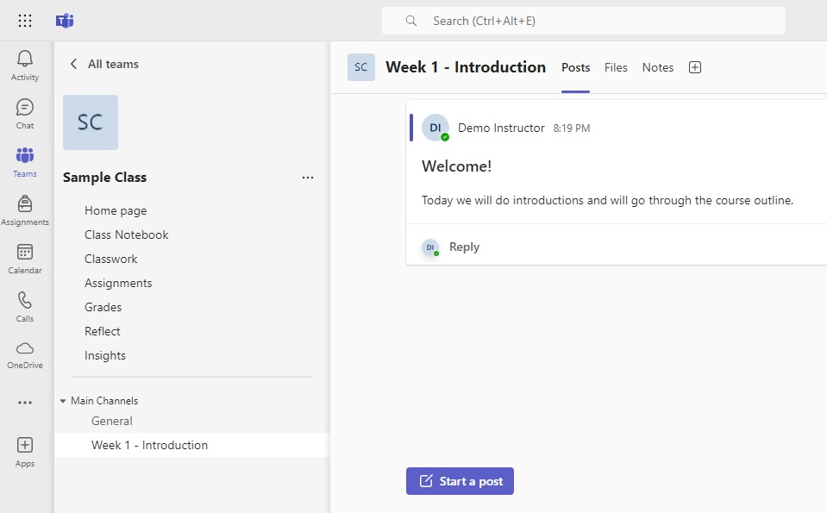

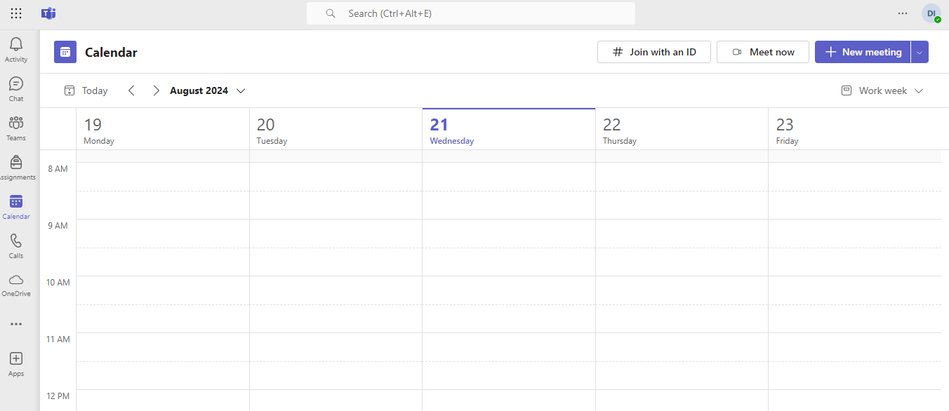

Click on the **+ New meeting** button to create your meeting.

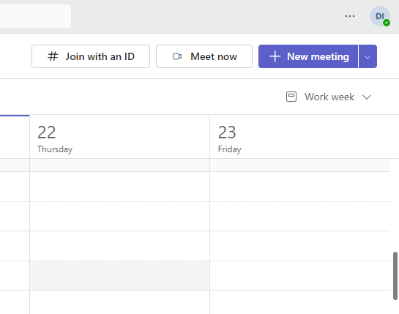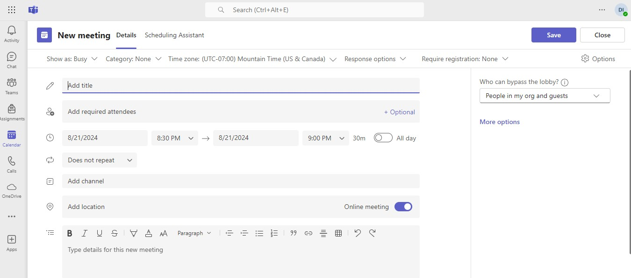

Set the day and time for your meeting

Add a title to your meeting

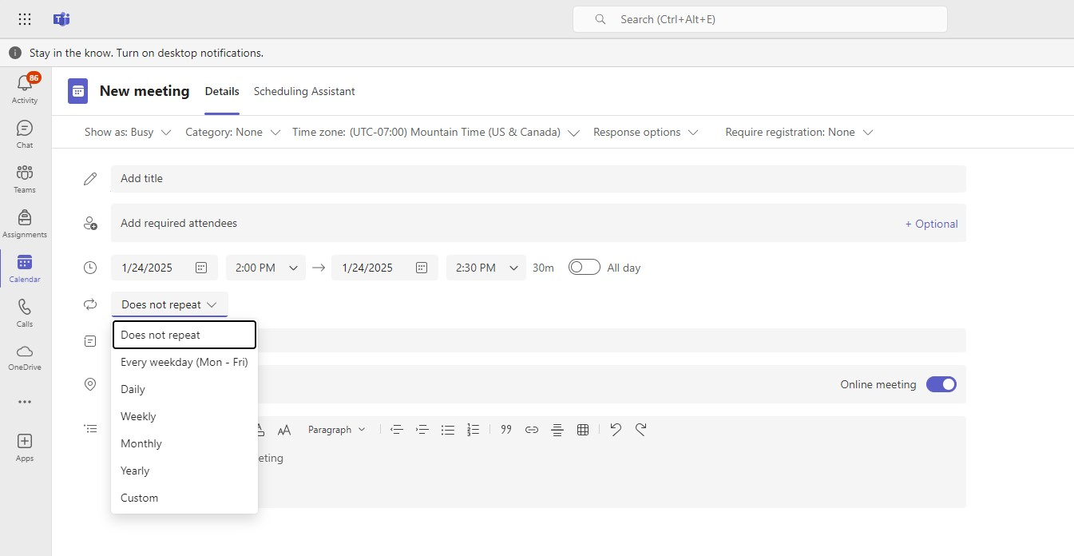

Click on the arrow beside Does not repeat to set up a reoccurring meeting. If your class is every Monday afternoon, select Weekly as an example.

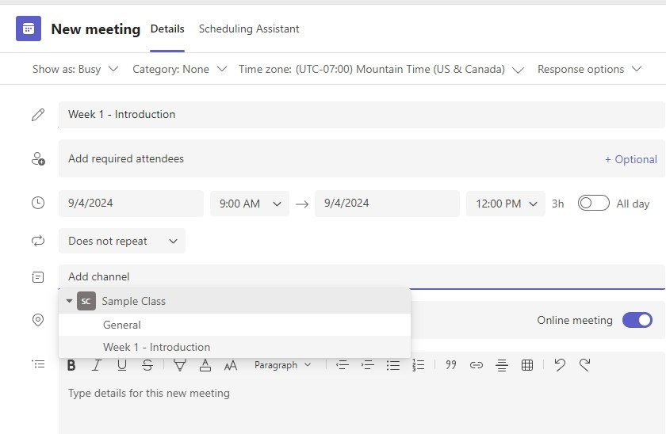

When you click on Add channel you can select the specific channel you would like the meeting to appear under. If you do not select Add channel the notice will appear under the General channel.

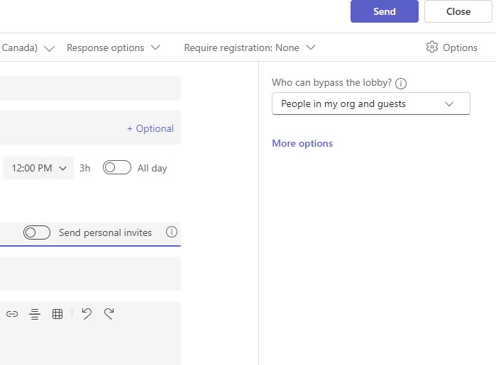

Click on **Send** to schedule the meeting.

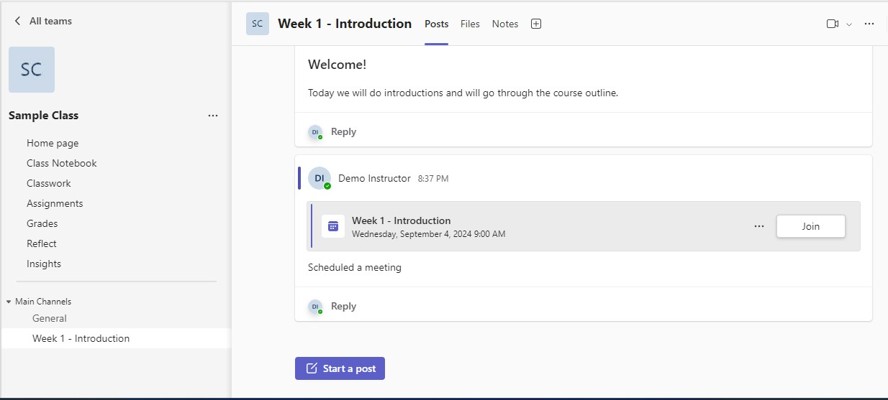

The link to join the meeting appears under the Week 1 - Introduction channel. When it is time to start your meeting you can click on the Join button here.

It also appears on the Calendar. Go Calendar, click on the arrow beside the current week.

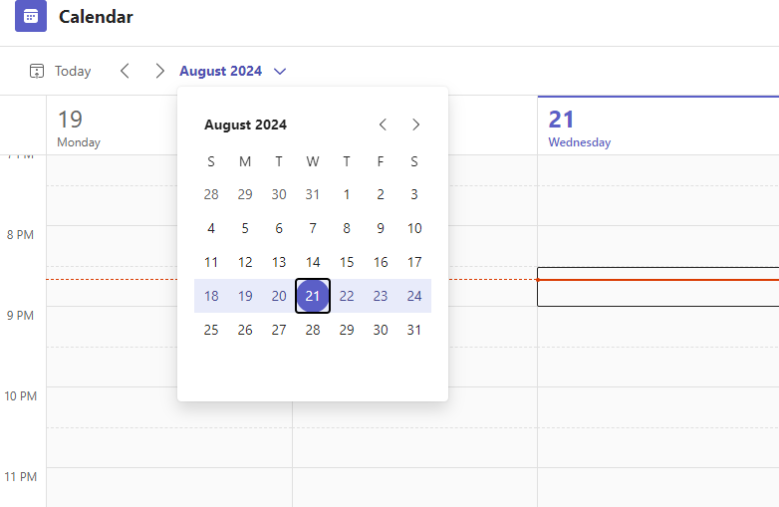

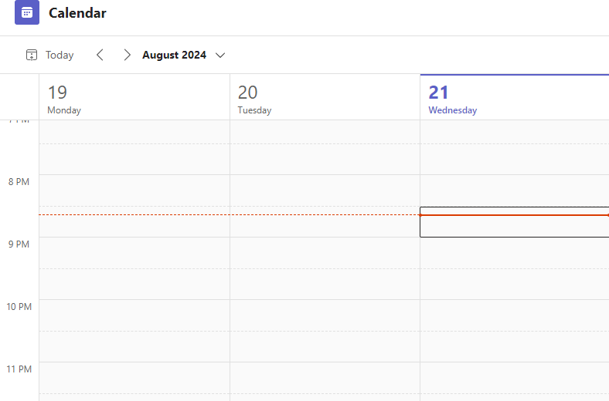

Click on the arrows to navigate to the correct month if necessary and select the date of your meeting.

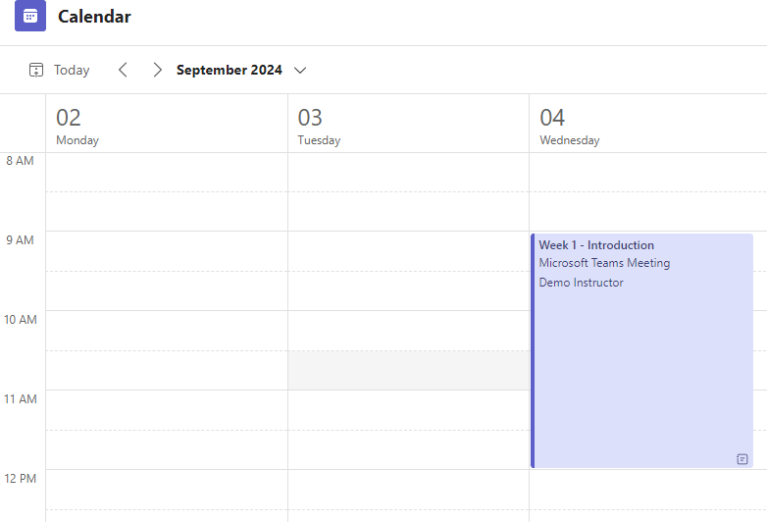

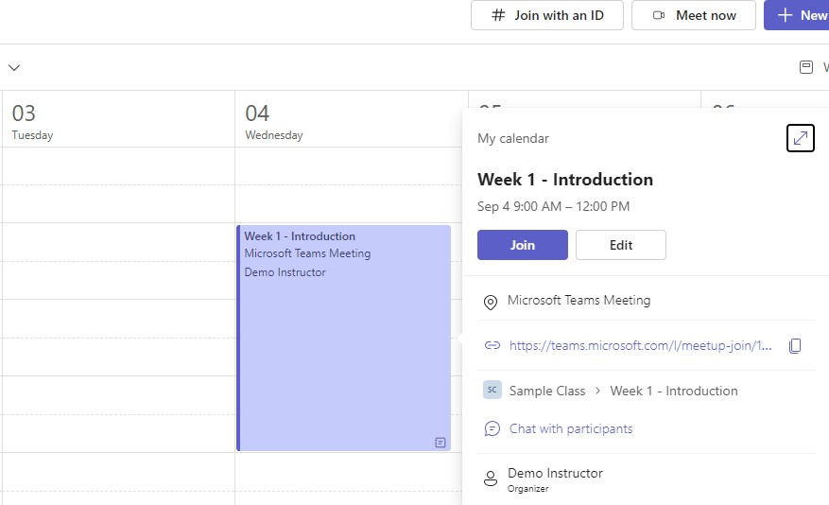

Click on the block for your meeting to Join or Edit.

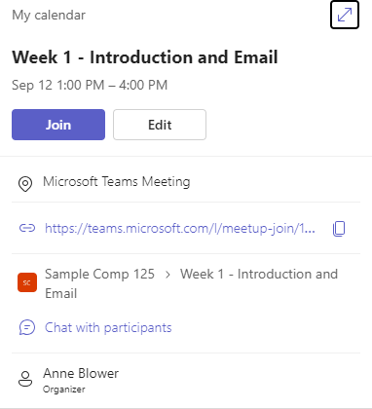

Click on the Join button to start your meeting.

You can also schedule a new meeting by going to Calendar and clicking on the block for the date and start time for your meeting.

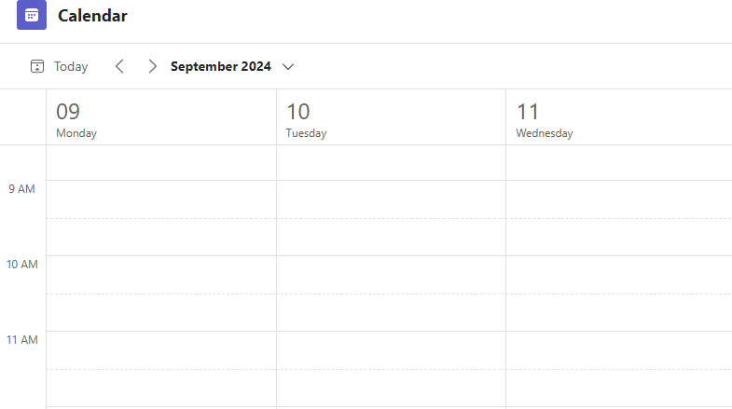

# Running your Teams Meeting

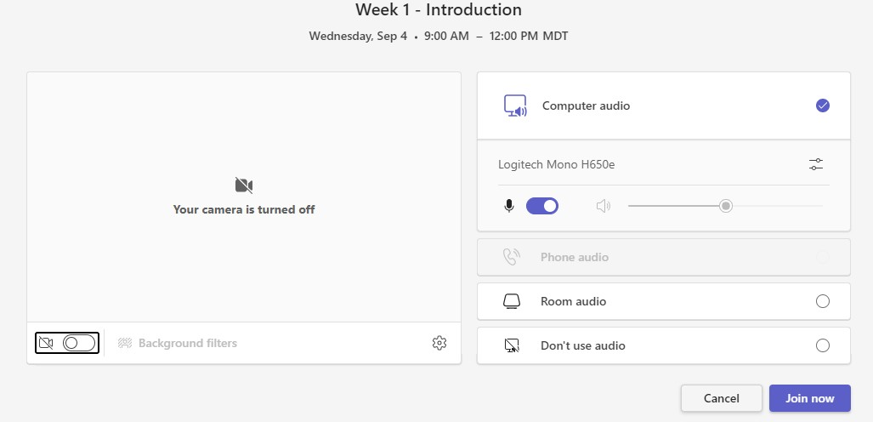

To turn your camera on click on the Camera button, (you can also set Background filters if you wish after you have turned on your camera) and then click on Join now button.

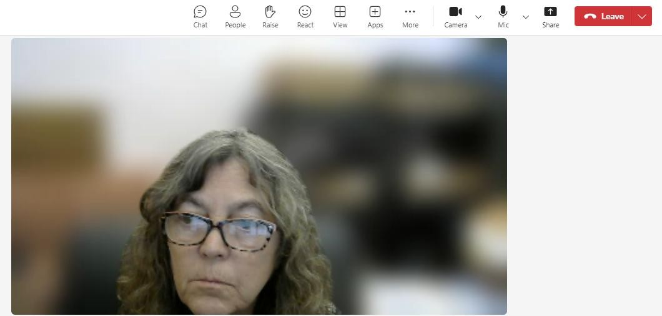

The buttons that you will be using to control your meeting are at the top of the meeting screen.



The **Show conversation** button is used for conversations during the meeting.

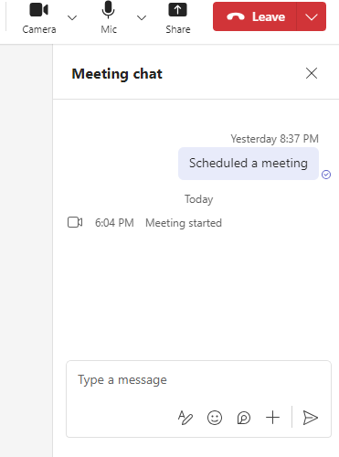

The **Show participants** button allows everyone to see who is in the meeting.

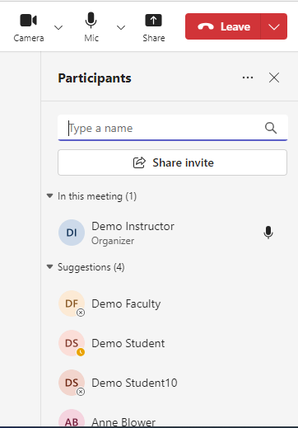

The **Raise your hand** button can be used to let the host of the meeting know you want to speak. **Demo Student has their hand raised.**

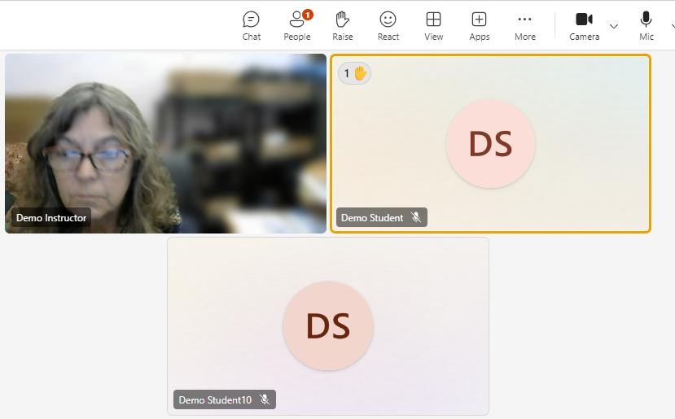

The **Send a reaction** button can be used to react to things during the meeting.

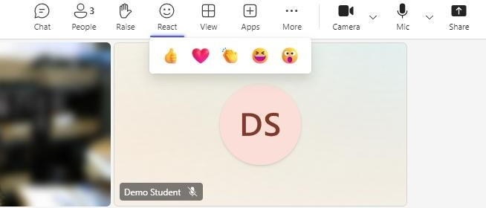

The **Change your view** button lets you select different views for your

screen.

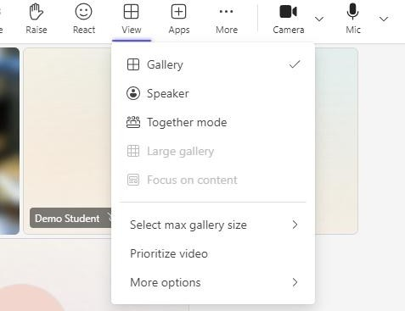

The **Add an app** button lets you add additional apps to your meeting.

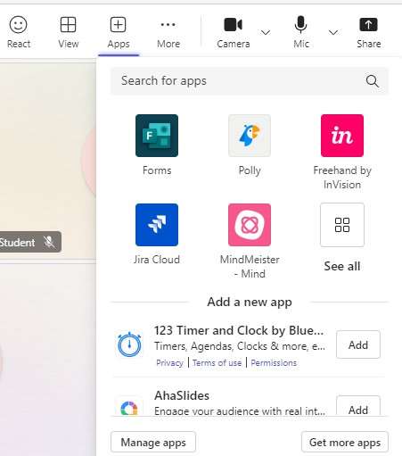

The **More actions** button brings up a menu with a number of helpful options. Record your meeting, setting for your camera and audio, etc.

You can also go to Setting and then Meeting options to control things like whether participants can use their cameras or microphones.

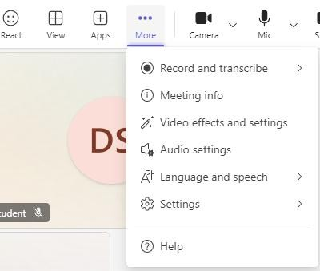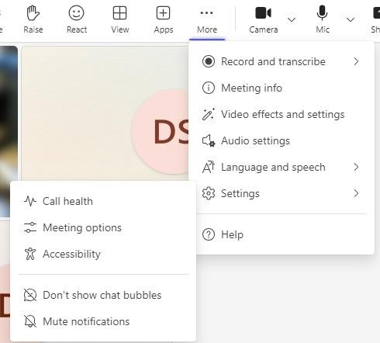

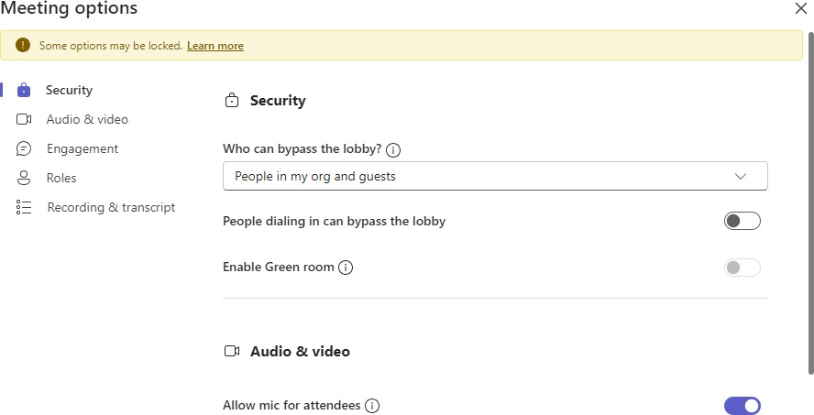

**Turn this option on if you want to receive attendance reports for your meeting!**

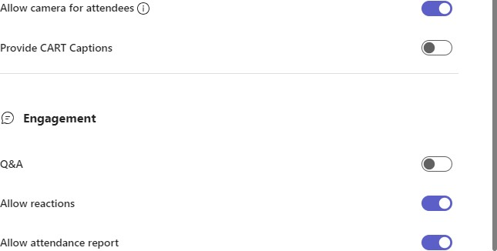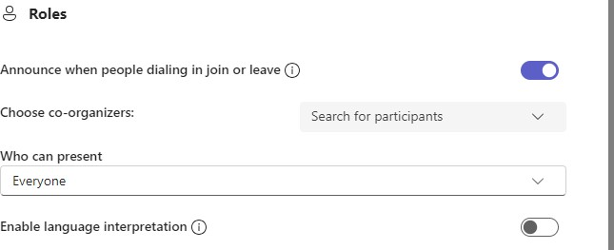

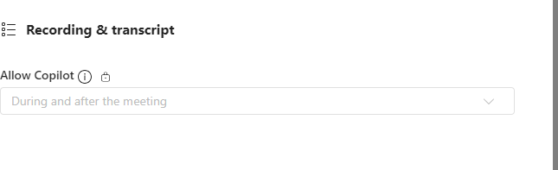



Click on Save when you are finished making selections.

**Use the Camera** button to control whether your camera is on or off.

Use the arrow beside the Camera button to select your camera or change backgrounds.

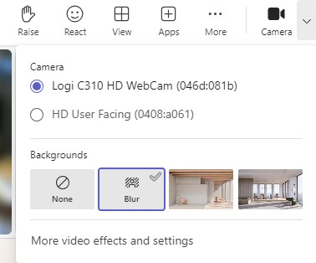

**Use the Mic** button to control whether your mic is on or off. Use the arrow beside the Mic button to select your mic or change settings.

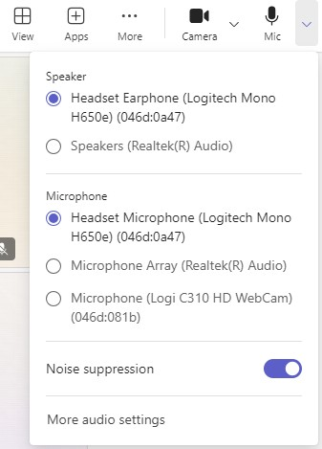

**Use the Share** content button to show material during the meeting.

Participants can share also.

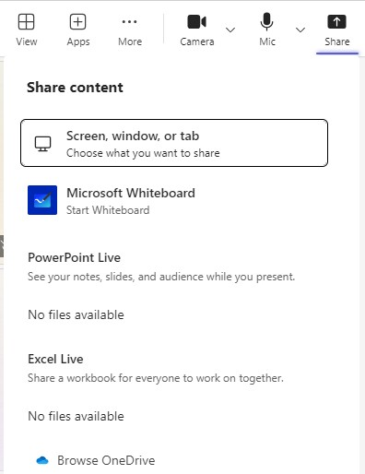

The first option allows you to share a Browser Tab. This option will be either Microsoft Edge or Chrome depending on which browser you are using.

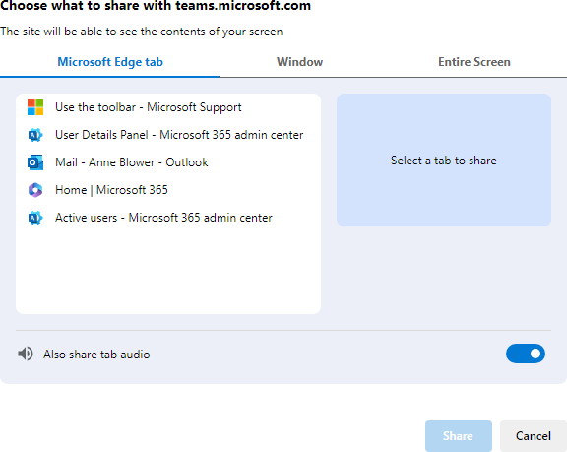

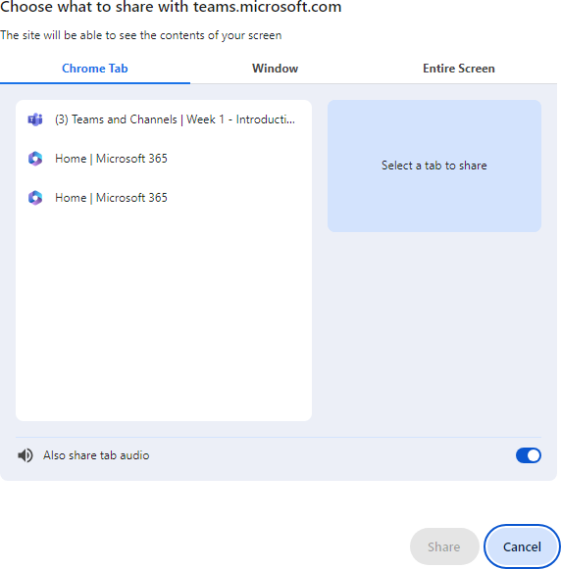

You can share a Window.

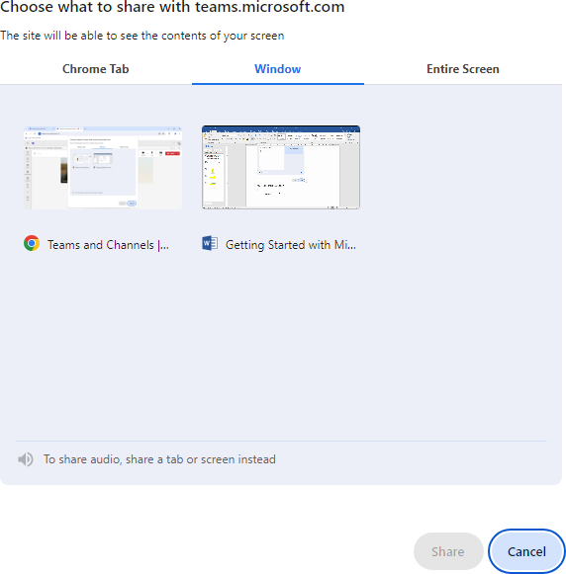

You can share your Entire Screen.

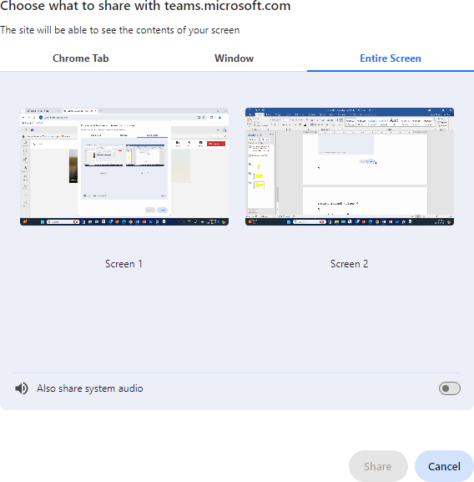

If you are wanting to play a You Tube video for example you will need to use either a Microsoft Edge Tab, a Chrome Tab, or Entire Screen so that you can also share system audio.

# Assignments

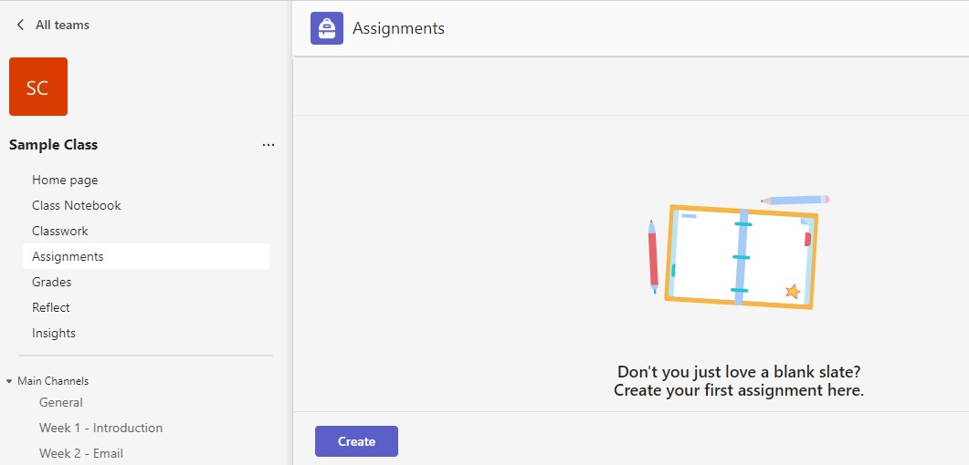

Click on the **Create** button to set up your assignment.

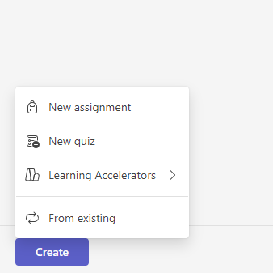

Click on **New assignment**.

This is the screen where you will set up your assignment.

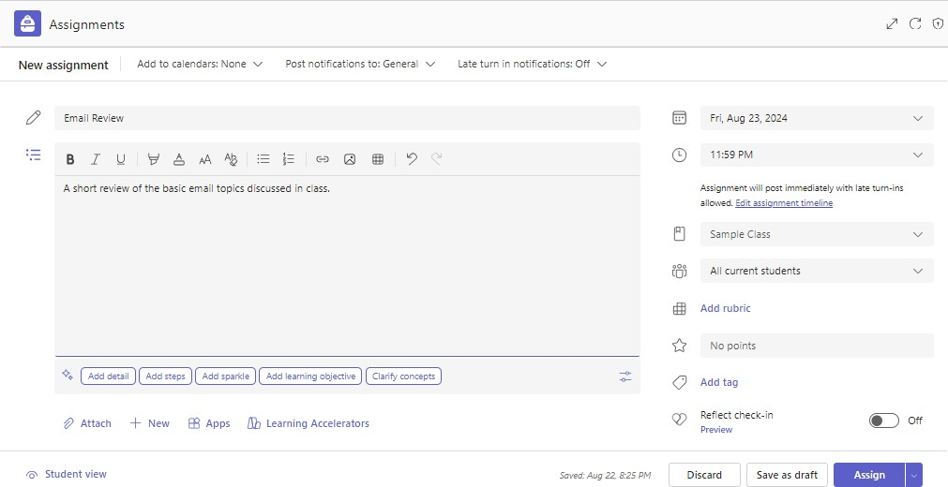

You can set the assignment to show in the student’s calendar.

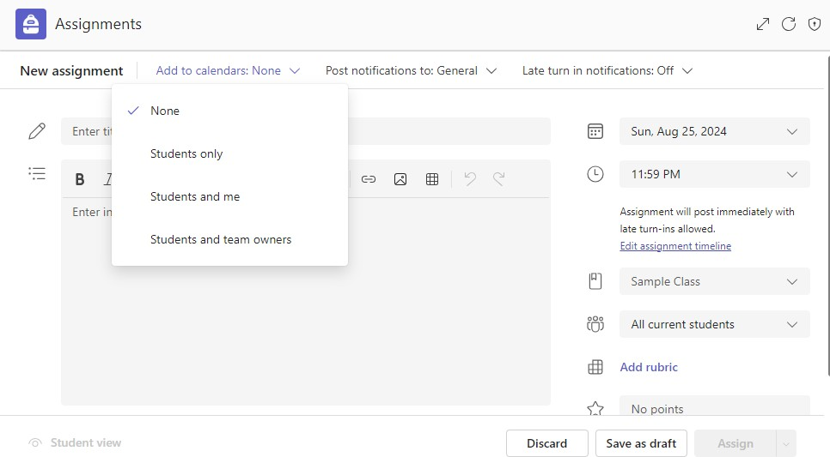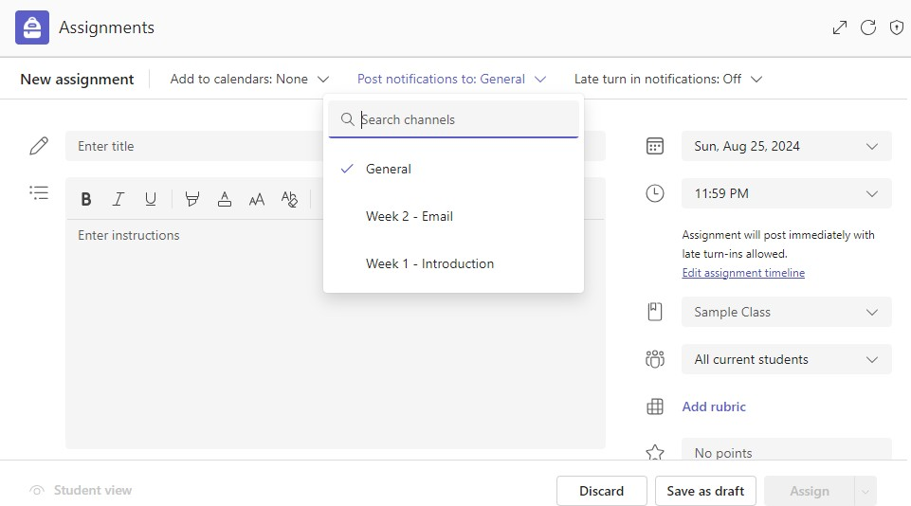

You can also set the assignments to show in a particular channel if you are using

additional channels.

Begin creating your assignment by entering a title and a description for the assignment.

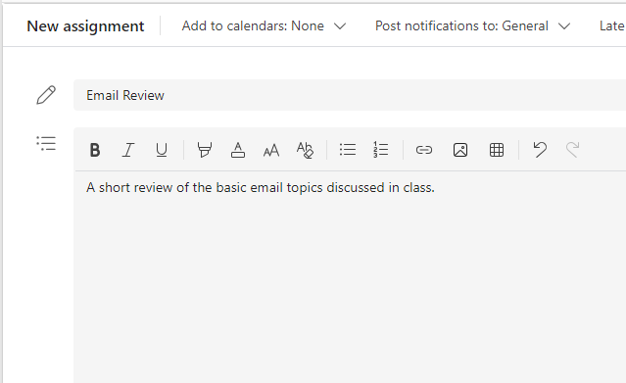

Next you would attach any file(s) needed for the assignment.

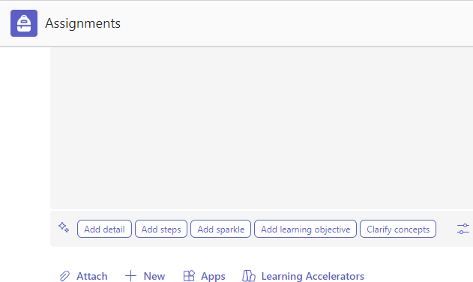

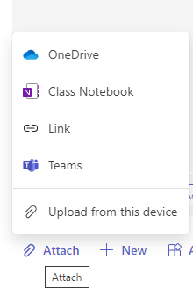

There are several choices, I am going to Upload from this device.

Navigate to where you have the file stored on your computer, select it and click on Open button.

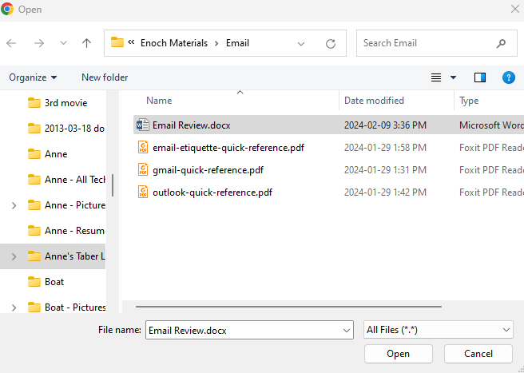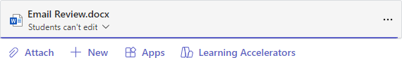

When files are attached they are read only. If I want the student to make changes to the file, I need to change this to Students edit their own copy. **(Please note: files must be saved in the newest file format for this to work)**

Click on the 3 dots to change this setting.

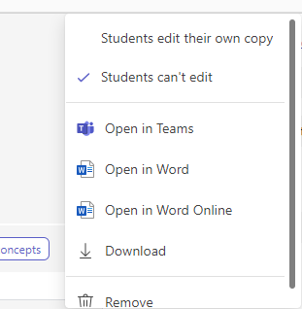

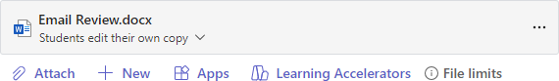

You can then schedule the date and time the assignment is due.

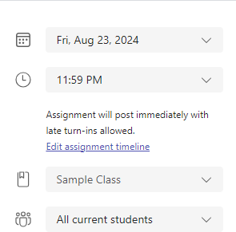

## You will want to change the All current students option to All current and future students. If this isn’t changed and a student is added to the class at a later date they won’t see the assignment. If you create assignments before you add the students, you MUST use All current and future students otherwise they won’t see the assignments.

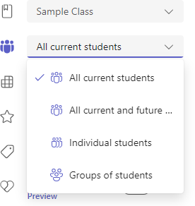

You can add points to the assignment. If this is done, when you mark the assignment the points you give the student will be automatically added to the grade book.

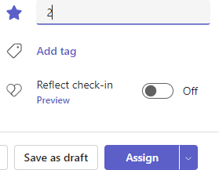

You can complete the assignment by clicking on the Assign button.

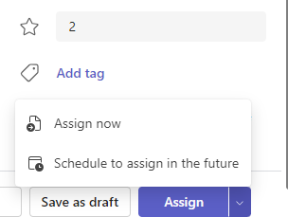

You can also schedule an assignment for a future date by clicking on the arrow beside the Assign button and selecting Schedule to assign in the future.

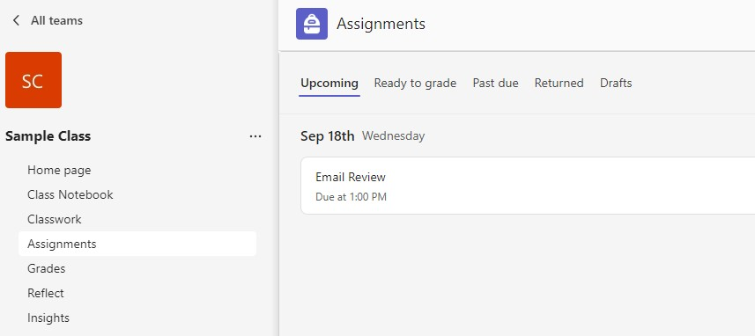

The assignment is posted and can be seen anytime by going to Assignments.

You can also go to the General channel to see posted assignments. Any changes you make like changing the due date/time will also be posted in the General Channel.

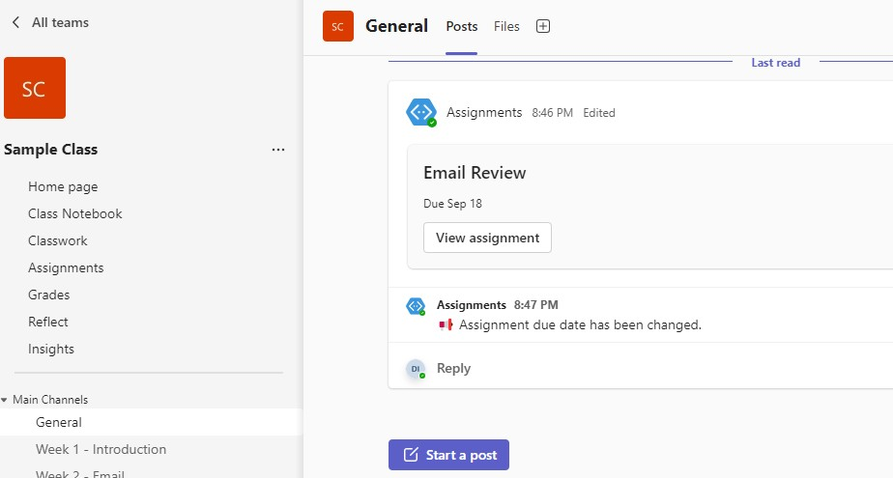

# Chats

You can also use the Chat feature to communicate with individual students or groups of students.

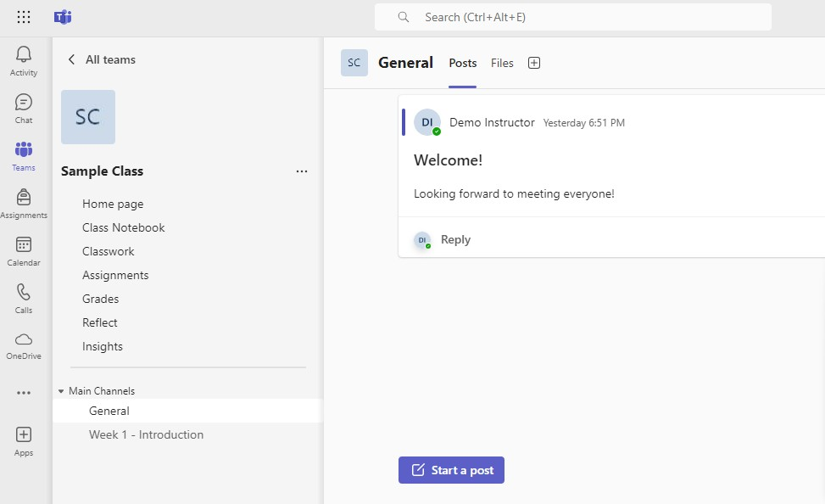

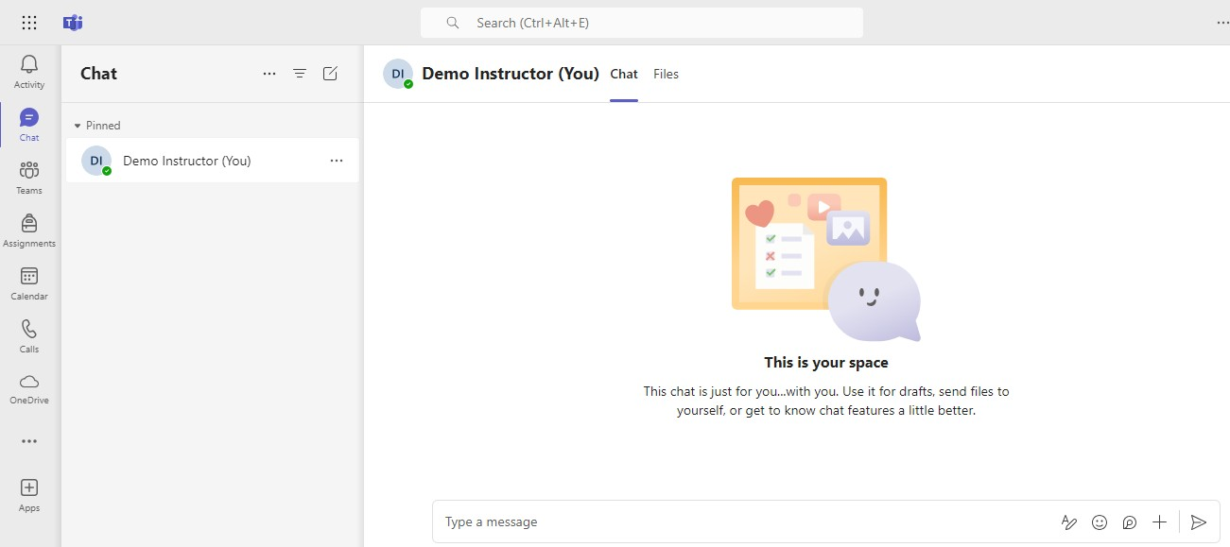

This space is for you only, to chat with someone else (or a select group) follow the steps below:

Click on the **New chat** button to start a chat with a specific student or teacher.

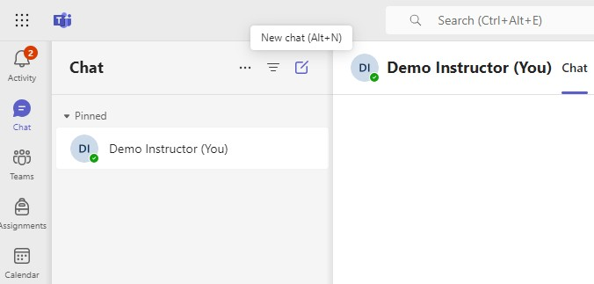

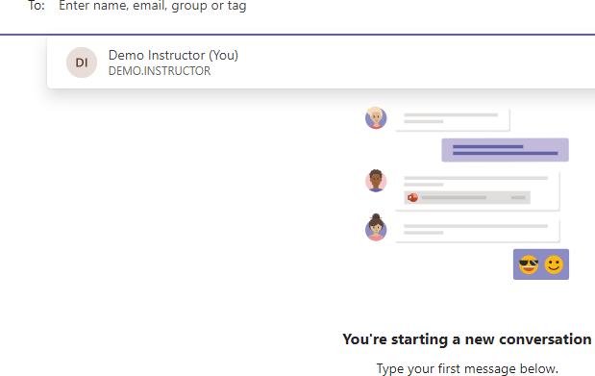

As you begin typing in the **To:** box a list of names appears. Select the person (or persons) you want to chat with.

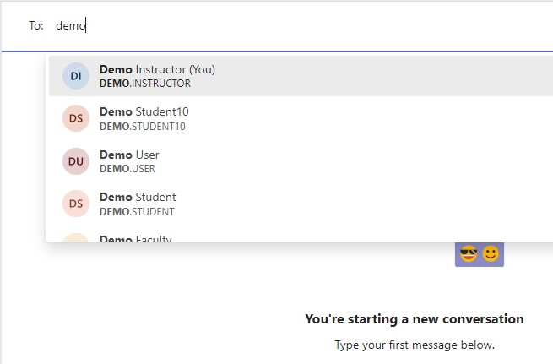

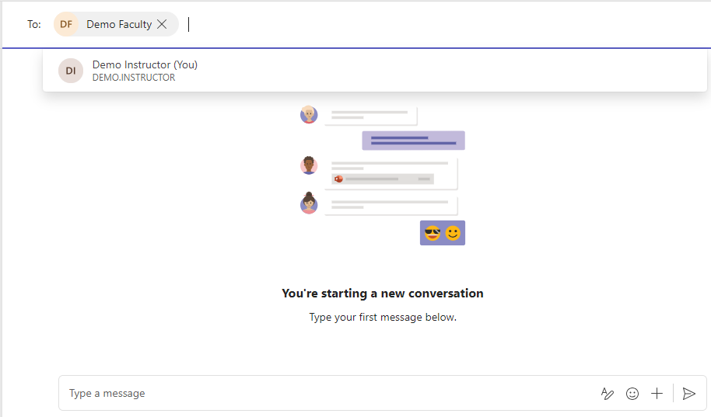

Click in the **Type a message** box to begin the chat.

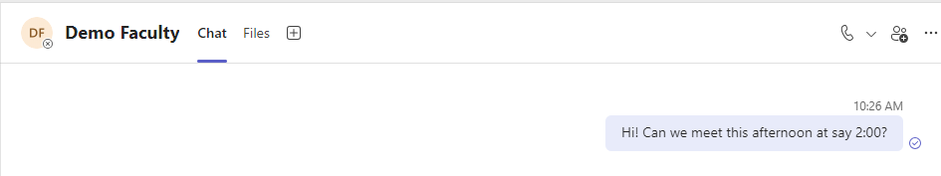

Click on the **Send** button to send the message.

# Meet now (Instant Meetings)

An Instant Meeting can be started by clicking on the Meet now button in the Calendar.

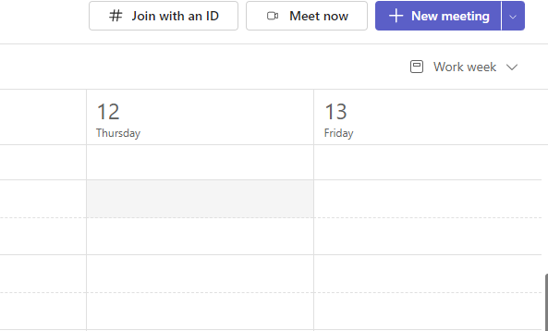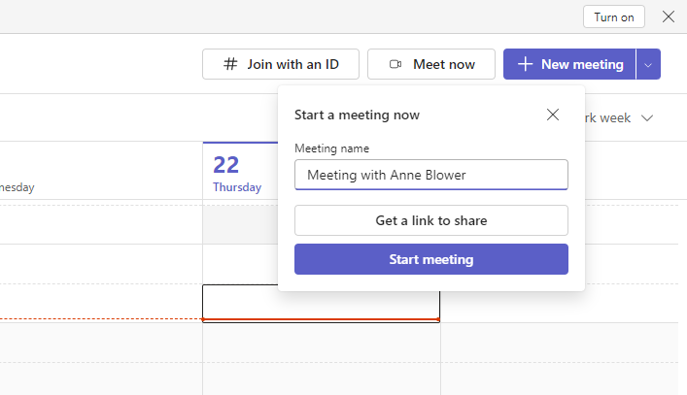

Click on **Start meeting** button

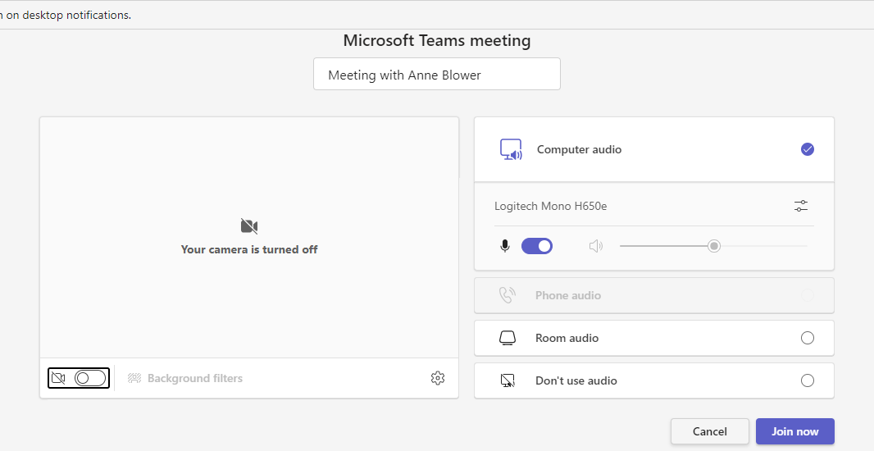

Turn on your camera (you can also set a Background filter if you wish).

Click on **Join now** button

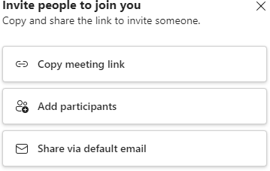

Click on the button - you can then email the link to the people you want to attend the meeting

**Breakout Rooms**

Breakout rooms in Microsoft Teams allow organizers/instructors to divide a meeting into smaller groups for focused discussions. Organizers/instructors can create, manage, and assign participants to breakout rooms either before or during a meeting. Participants can then join these rooms, participate in activities, and collaborate within their smaller groups.

To create a breakout room, follow the instructions below.

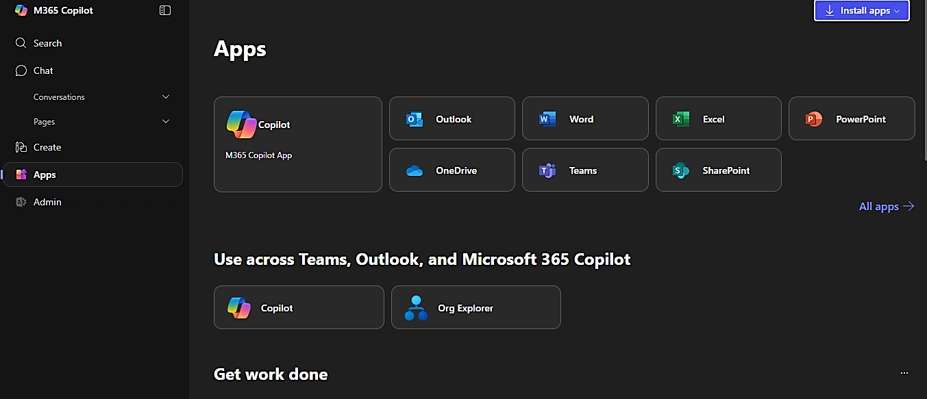From your co-pilot page, click on Apps (indicated by the blue arrow) and then click Teams (indicated by the yellow arrow in the second picture).

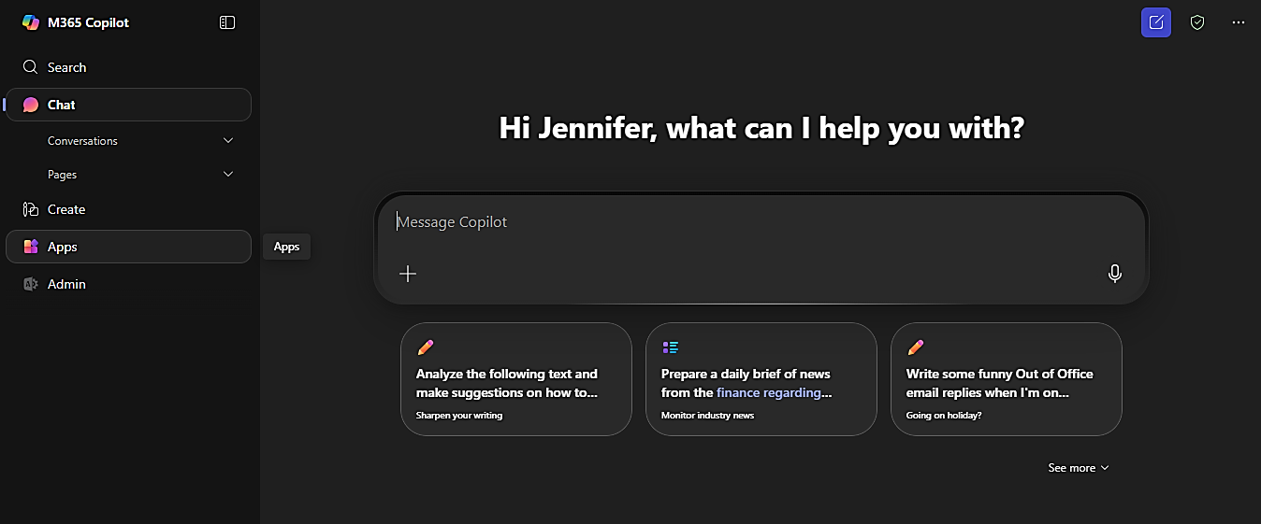

Once you are in Teams, click Calendar from the left hand column.

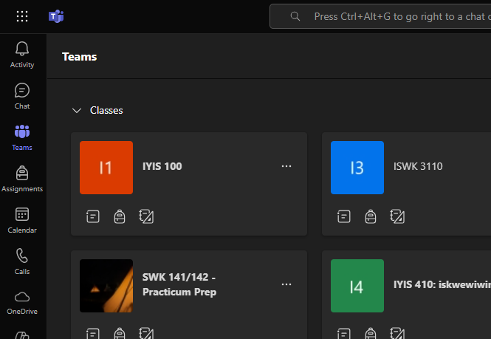

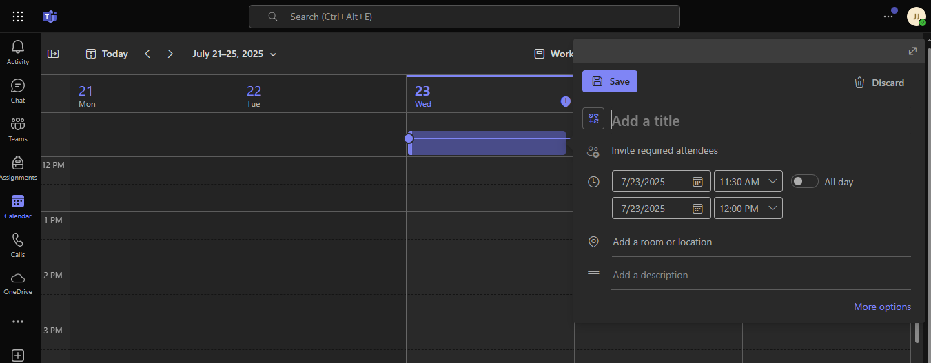Once you have been brought to the Calendar page, you will be able to create a meeting. Click the date and time you would like to schedule a meeting and a meeting box will pop up as shown below.

Fill in the meeting box with all the necessary information such as title of the meeting, invite required attendees (such as students within your class), the time and date of the meeting.

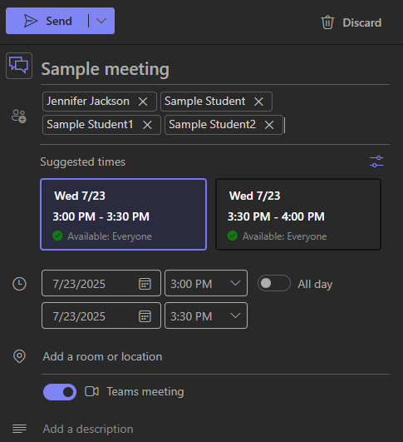

Title

Required attendees

Time and Date

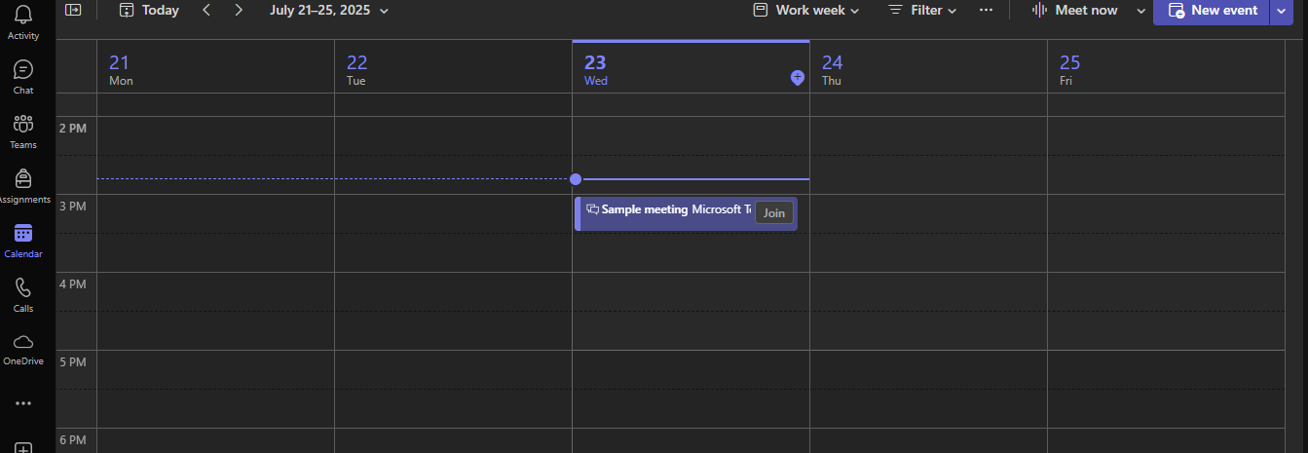Once you have filled out the information, click on Send. You should see the screen below once you click on Send.

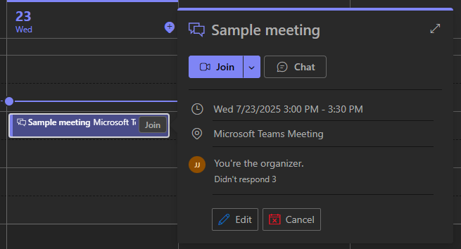To create a breakout room within the meeting you just created, you will need to edit the meeting details. Click on the meeting ‘bubble’ (indicated by the blue arrow) and then click on edit (indicated by the yellow arrow).

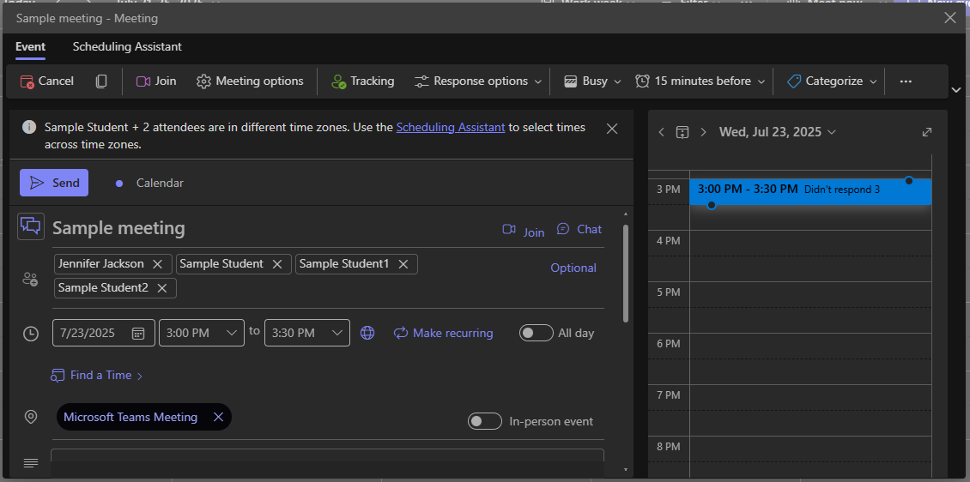You should see the following screen once you clicked on Edit. On this screen, to create Breakout Rooms, click on the ellipses (3 dots) in the top right corner of the screen as indicated by the blue arrow.

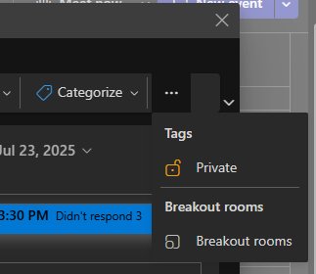Once you have clicked on the ellipses, you should see the following pop up box. You will then click on Breakout rooms indicated by the blue arrow.

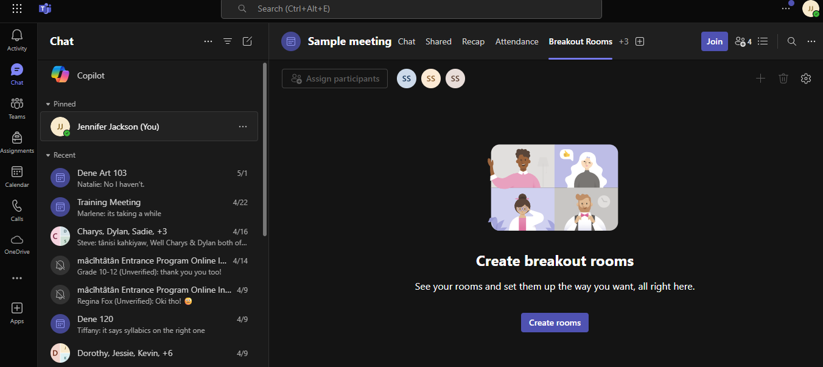Your screen should look like the picture below. You then want to click on Create rooms.

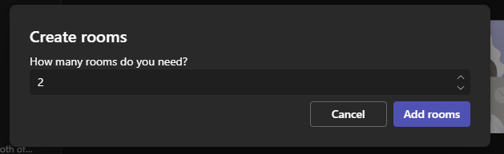Once you click on Create rooms, you should see the image below. This is where you will decide how many breakout rooms you want. Either click beside the number (blue arrow) or click on the directional arrows (yellow arrow) above Add rooms. Once you decided how many rooms you want, click on Add rooms.

You will then see the screen below. You can assign participants to specific rooms on this page. You can also rename the rooms if you choose as well. To assign participants to a breakout room, click on Assign participants (indicated by the blue arrow). If you would like to rename the breakout room, click the ellipses (3 dots) in the upper right corner of the breakout rooms (indicated by the yellow arrow) and then click on Rename.

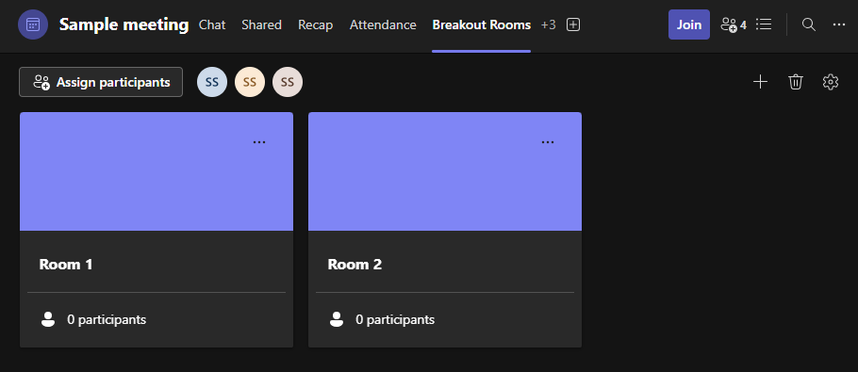

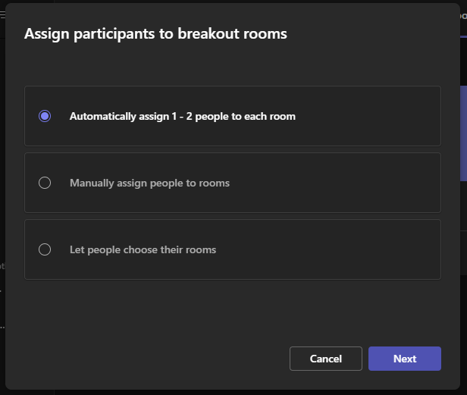If you click on Assign Participants, you should see the following screen. You will see Automatically assign 1-2 people to each room, Manually assign people rooms and Let people choose their rooms. This is completely up to you as the instructor as to how you would like the assign people to the rooms. Once you choose one of the three options, click on Next.

You have now created Breakout rooms for your meeting/class.

# Breakout Rooms on the Teams App

Breakout rooms are also available in the installed version of Microsoft Teams. You can download Teams from the Microsoft store.

To download the Teams App to your computer, Click on the **Start** button.

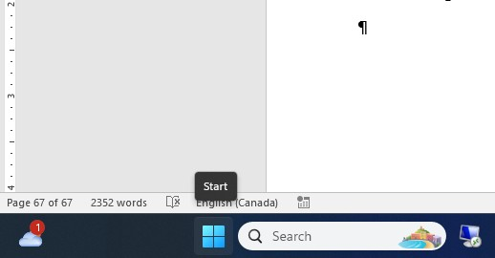

Go to **All apps**

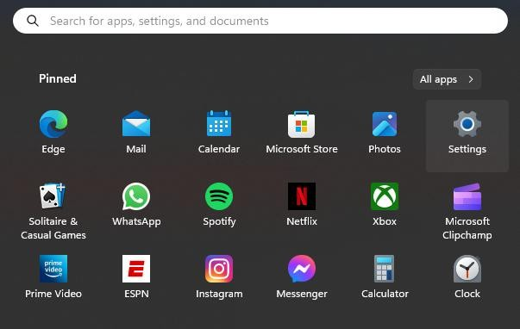

Select **Microsoft Store**

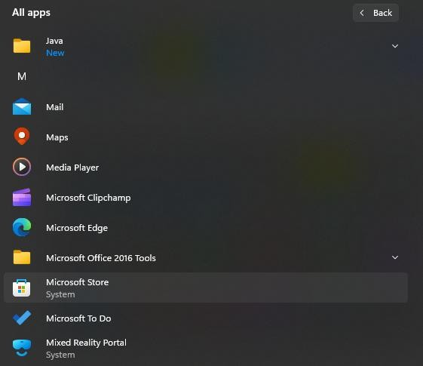

Type in **Microsoft teams**

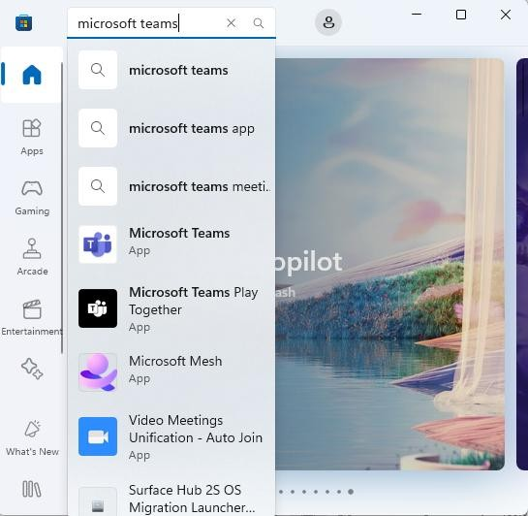

## Select the top option in the list

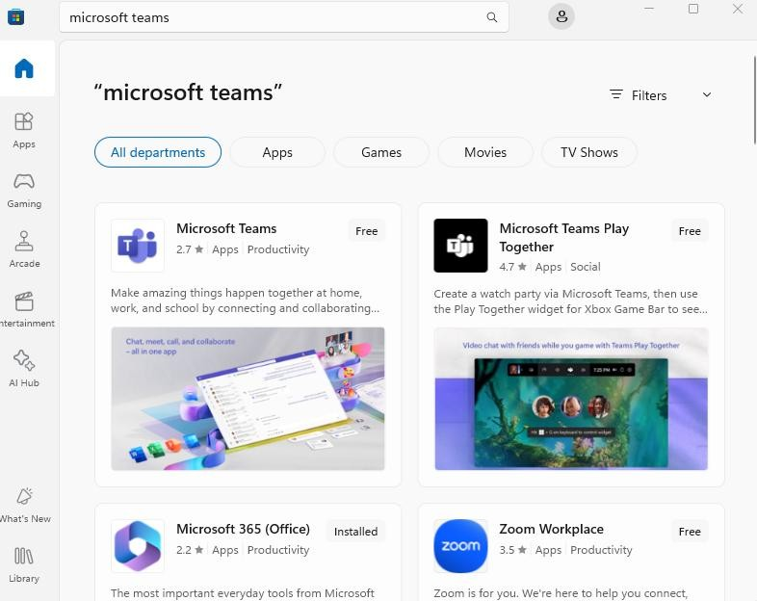

## Click on the Microsoft Teams block.

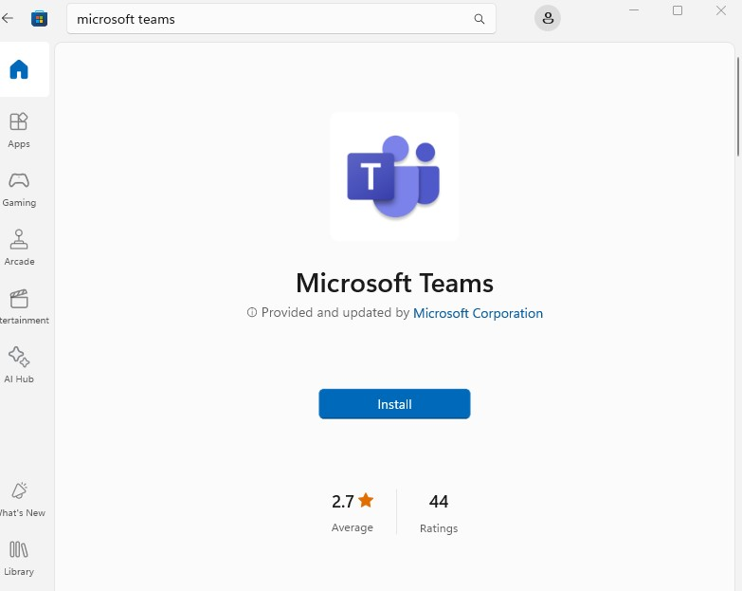

Click on the **Install** button

Open the installed Teams App. If the icon is not on the Taskbar click on the Start button and go to All Apps.



## Scroll down to Microsoft Teams and click on it.

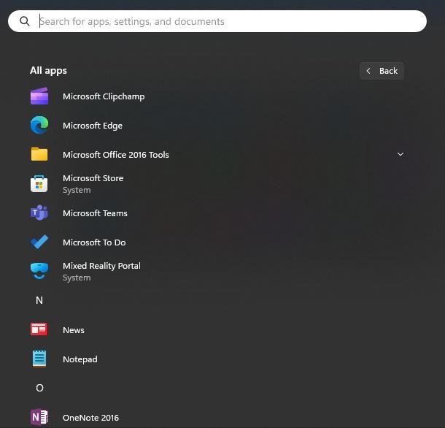

If Teams is not on your Taskbar, right click on it in the Start menu and select More, then Pin to Taskbar.

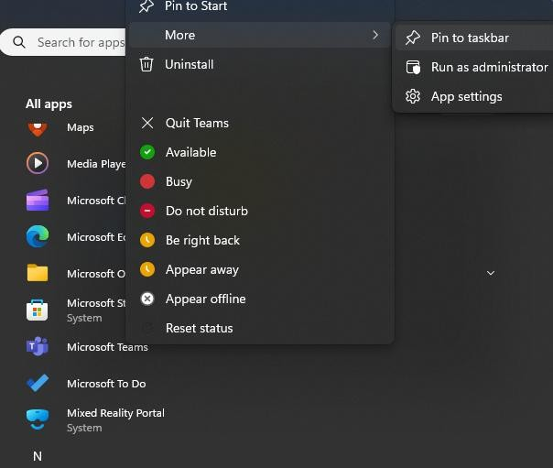

If this a shared computer, like our classrooms there may already be accounts listed.

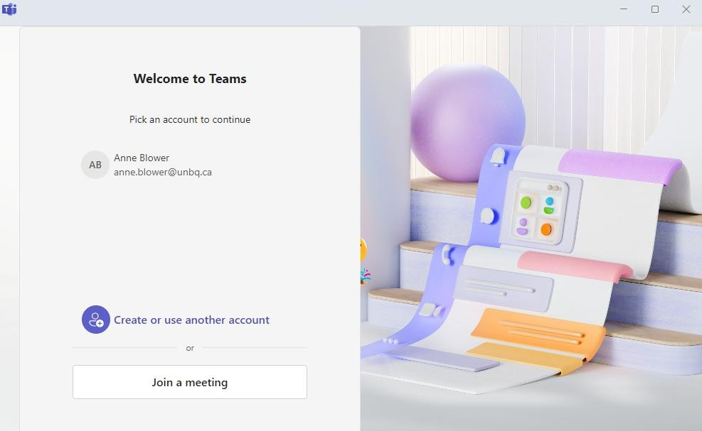

Click on **Create or use another account** to sign in.

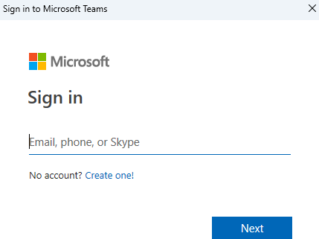

Type in your unbq.ca email and click

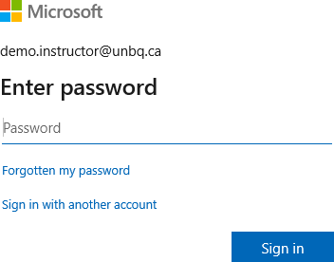

Type in your password and click on **Sign in**

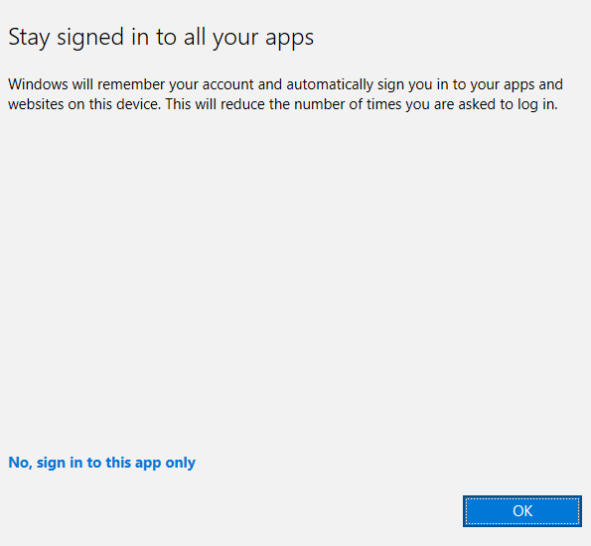

**If this a classroom computer at Blue Quills select No, sign in to this app only**. If this is your personal computer, you can click on OK.

Start your online meeting. Click on the **Breakout rooms** button.

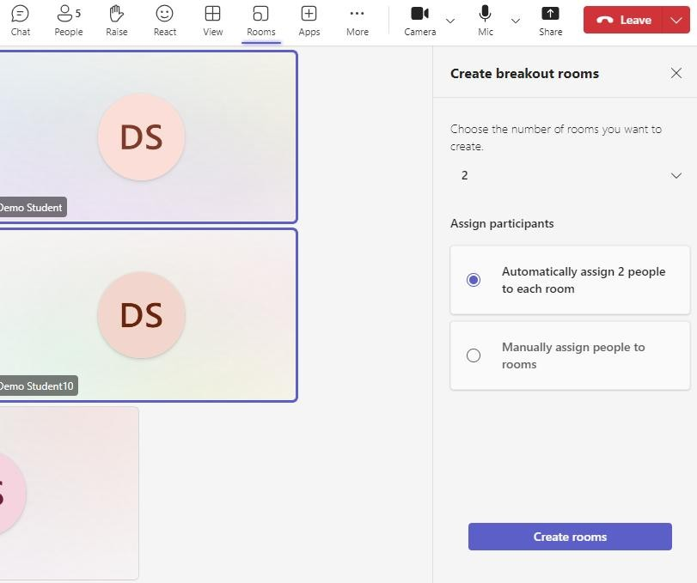

Choose the number of rooms you want to create.

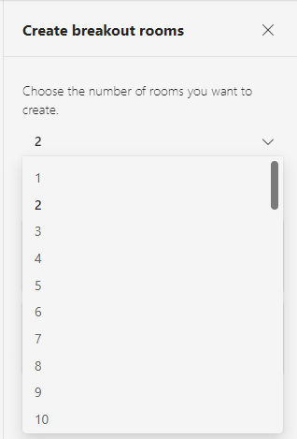

Select **Automatically assign** to let Teams decide who is in each room and then click **Create rooms** button.

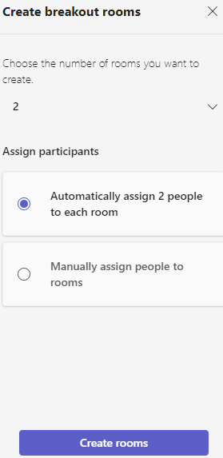

This is what you will see when you choose the Automatically assign option.

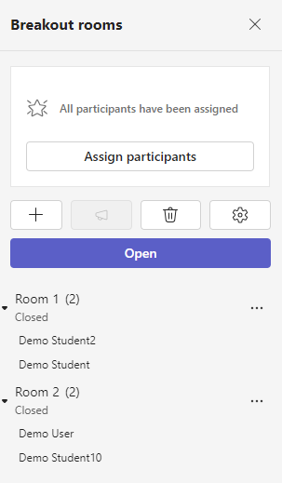

If you want to assign specific students to groups use the **Manually assign people to rooms** option and then click the button.

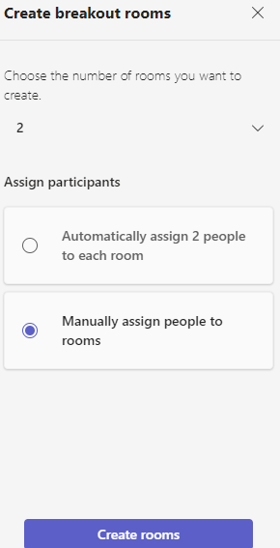

Click on Assign participants to assign to rooms.

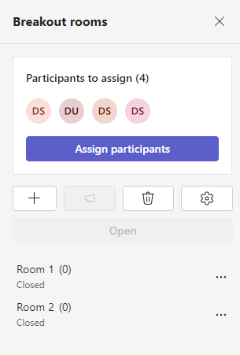

Click on the dropdown arrow beside unassigned for each participant to select room.

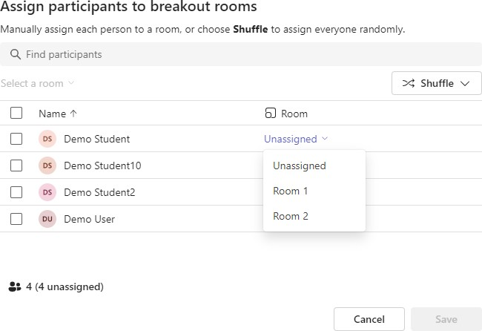

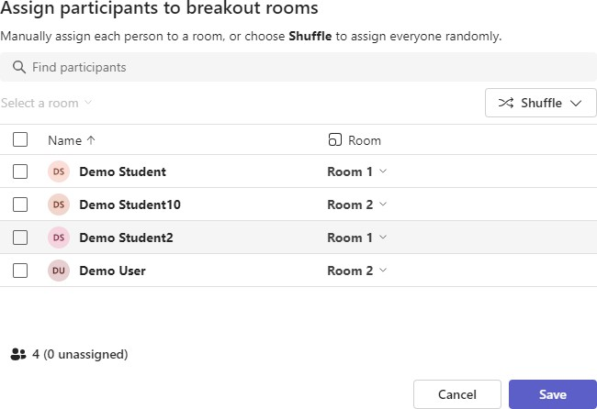

When you have assigned all the participants to room click on the **Save** button.

Click on the Open button when you are ready to have everyone go into their breakout room.

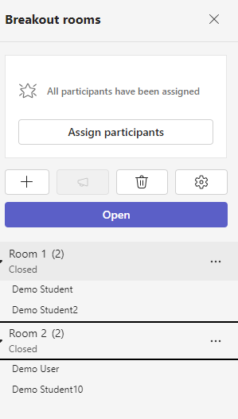

Breakout room 1

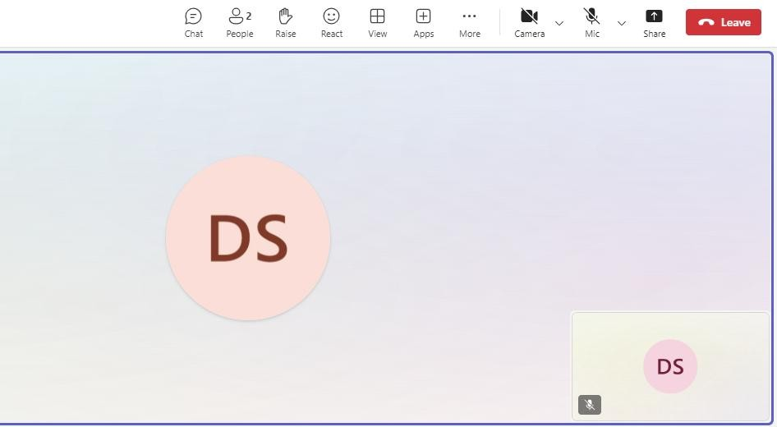

Breakout room 2

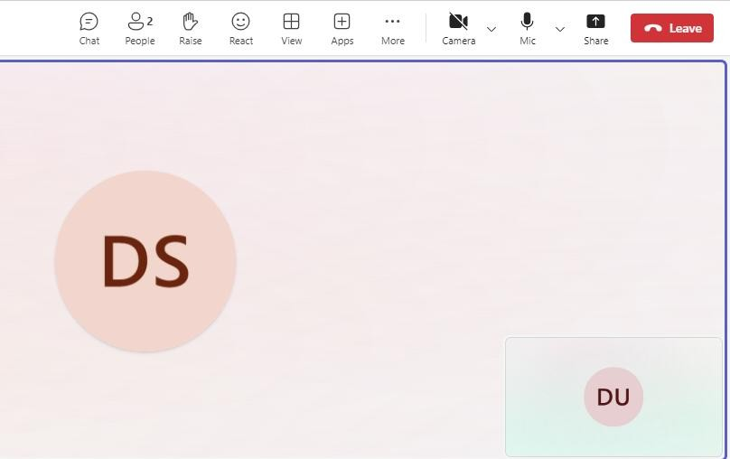

When it is time to end the breakout sessions you can Close rooms.

